
There is no visit in August.
August 2024

Dear Member

I am pleased to be able to tell you that we have a new website which is basically up and running: https://severntreetrust.co.uk . It’s early days and therefore possible that you may spot one or two items that need tweaking, most of these are in hand. It will be possible in the near future for any member to add suitably interesting material, including photos, to the site. Details of how to do this will appear as soon as possible.
May I thank Sonia Swain for agreeing to take on the basic work of keeping the site up to date along with help from other members.
In addition my thanks to Johanne Brachi and Angela Hughes who were also instrumental in gathering together ideas and suggestions and contacting the person who has set this up for us.
It is going to be a terrific way of keeping in contact with members, reminding everyone of what is going on and showcasing what we do and hope to do in the future for potential new members.

I hope you are enjoying the summer but don’t forget to keep any newly planted trees watered especially as it looks as if we may have an extended dry period.
Julie Kaye

Visit to Ness Gardens on the Wirral. Saturday, 14 July 2024.
(photos in Appendices)

This time a whole day was organised for us by Peter Aspin and what a great job he'd done. For those who wished, they could have met him at the RSPB site at Burtonmere before making an early start at Ness Gardens. So the visit to Ness was more or less a whole day visit, veering away from our normal half-day visits. But if you're travelling that far, you'll really want to get the most out of it? In fact, some members stayed overnight locally to avoid a long early drive.

Angie and I turned up at lunchtime to have something to eat in the Ness Gardens café before meeting the group for the afternoon session. The café is very good and does hot meals as well as snacks, something well worth remembering. As soon as we'd finished the group turned up, told us exactly which part of the gardens they'd covered so that while they ate a lunch we could look at what we'd missed then the whole group would convene for the afternoon session.

It's a very large site – 64 acres - and, even with a whole day for us to explore, we didn't cover it all.

Ness Gardens was originally farmland where a certain Arthur Kilpin Bulley, in 1898, bought 30 acres of land with a view to building a house – Mickwell Brow - and creating a garden of interesting trees and other plants. In fact, Bulley employed some of the well-known plant hunters such and George Forrest and Frank Kingdon-Ward to collect plants from China and the Himalayas for him. Bulley died in 1942 and it was in 1948 that his daughter gave the house and gardens to Liverpool University. Over the ensuing period, the university has bought more land and it is this institution's efforts that have increased the site to the 64 acres it is today.

You may have heard of Bees Seeds Limited. This was a company set up by Bulley in 1906 and was originally established at Ness. When Forrest returned from the Far East with some unknown specimens, he named some of them in promotion of the Bees Seeds Company – e.g. Primula beesiana, Jasminium beesianum and Allium beesianum.

But it has been Liverpool University, particularly under the direction of a Ken Hulme, that has created the gardens we see today. Hulme was a skilled plantsman and devoted his life to “transforming the gardens into an attraction of importance”. It was under Hulme's direction that the Rock Garden was redesigned and the Pine Wood created. “Hulme also oversaw the planting of many important trees including the beginnings of a comprehensive collection of Sorbus and Betula, a collection that has been developed in more recent years by Dr. Hugh McAllister.” (All quotes from the leaflet: A short history of Ness Botanic Gardens).

As I write a report on one of our visits this time, I'm going to stay clear of just giving you long lists of the trees we saw. There are many species of tree here, some familiar and some not so, and it really is a site very well worth visiting....and returning to. So I'll stick to some of the trees that are either rare or have unusual characteristics.

I'll mention the fig tree first because the one we saw stuck in my mind as it was absolutely
loaded with fruit and I was familiar with its very unusual form of pollination. I won't bore you with too much detail as you can read about it in a very thorough explanation in Colin Tudge's book “The Secret Life of Trees” but briefly, pollination of fig trees depends on the fig-wasp and it's method of pollination is worth reading about. Tudge relates how, to be pollinated, all figs depend on the fig-wasp, wherever they are in the world. So I asked myself, what is unusual about the fig-wasps in Britain and how do they differ from the common wasps we see? For one thing, they are black. So the next time you're near a fig tree and you can see the flowers in blossom, see if you can see this black fig-wasp. It's not collecting pollen, it's depositing its eggs. The wasp then dies and the eggs hatch and its the newly developed wasps from the larvae produced that allow the pollen to stick to them and distribute it when they, themselves, lay their eggs in another fig flower. I said I'd be brief. Sorry. But it is a remarkable story with quite a difference from the usual pollination one.

We saw at least two Pocket-Handkerchief Trees, Davidia involucrata. Their large white bracts that look like handkerchiefs had obviously appeared in May because the trees were now sporting their glossy green 'balls' of fruit which will eventually turn brown. These trees take about twenty-five years to grow their inconsequential flowers and showy white bracts.
So if you want to plant one for your own garden, beware, you'll have to wait a long time before the 'handkerchiefs' appear. Some of our group remarked that they had never before seen the fruit of this tree so were pleased to have had a first sighting.

There was a large Wellingtonia (Sequoiadendron giganteum) at one place in the gardens and alongside it was the cut down stump of another. This stump clearly showed its annual rings which I counted to be thirty-four. Yet its girth was about 85 inches. That's a large girth for only 34 years, but if you looked at the rings they were spaced well apart which tells us something of the climate at Ness. Each ring was made up of lots more xylem cells to draw up lots more water which is only possible in rainy seasons. So you can conclude from that what you wish!

An unusual tree that many of us had never seen before was Tetracentron sinense. This had very attractive leaves. They had bright red petioles and their leaves were prolifically toothed with each tooth ending in a red colour. E.H.Wilson has an amusing tale to tell of this tree about his climbing of one in Hubei Province, China, in order to photograph the upper branches of a neighouring Davidia: “By climbing a large Tetracendron [sic] tree growing on the edge of a cliff and chopping off some branches to make a clear space, I managed to take some snapshots of the upper part of the Davidia tree in full flower. A difficult task and highly dangerous. Three of us climb the tree to different heights and haul up axe and camera from one to another by means of a rope. The wood of Tetracendron [sic] is brittle and the knowledge of this does not add to one's peace of mind when sitting astride a branch about 4 inches thick with a sheer drop of a couple of hundred feet beneath.” Needless to say, the timber of this tree is not very useful.

I could go on..and on about many more trees we saw. So many were of great interest...the Strawberry Tree (Arbutus unedo) for example, the specific name “unedo” meaning “I eat one” because after eating one, you won't want to eat another! And its cousin from North America, the Madroña (Arbutus menziesii). Or the Swamp Cypress (Taxodium disticum) with its “knees” (pneumatophores) above the water. But I must stop.

I did say that I wouldn't give you a list of the trees we saw but just select a few of interest. Neither did I want to take you step by strep around this amazing garden So I'll just finish by telling you about the long floral and shrubby border called “The Mexican Border.” We didn't see Donald Trump there or any signs of his fence!

Thank you Peter for an excellent visit. We must visit Ness again. John Tuer

Notes from Shetland, by Angela Hughes

A surviving sycamore, one of three sycamores planted in the garden of the house behind, now a shop in the centre of Kirkwall, Shetland.
The Council stepped in to save the tree when two of the trees were felled and bought it to save it. The tree remains the property of the Shetland Council and still in leaf this July in spite of the paving slabs right up to the trunk and the metal pole helpfully propped inside.
Planted by Robert Laing sometime between the dates 1722 to 1803 as shown in the photo below.

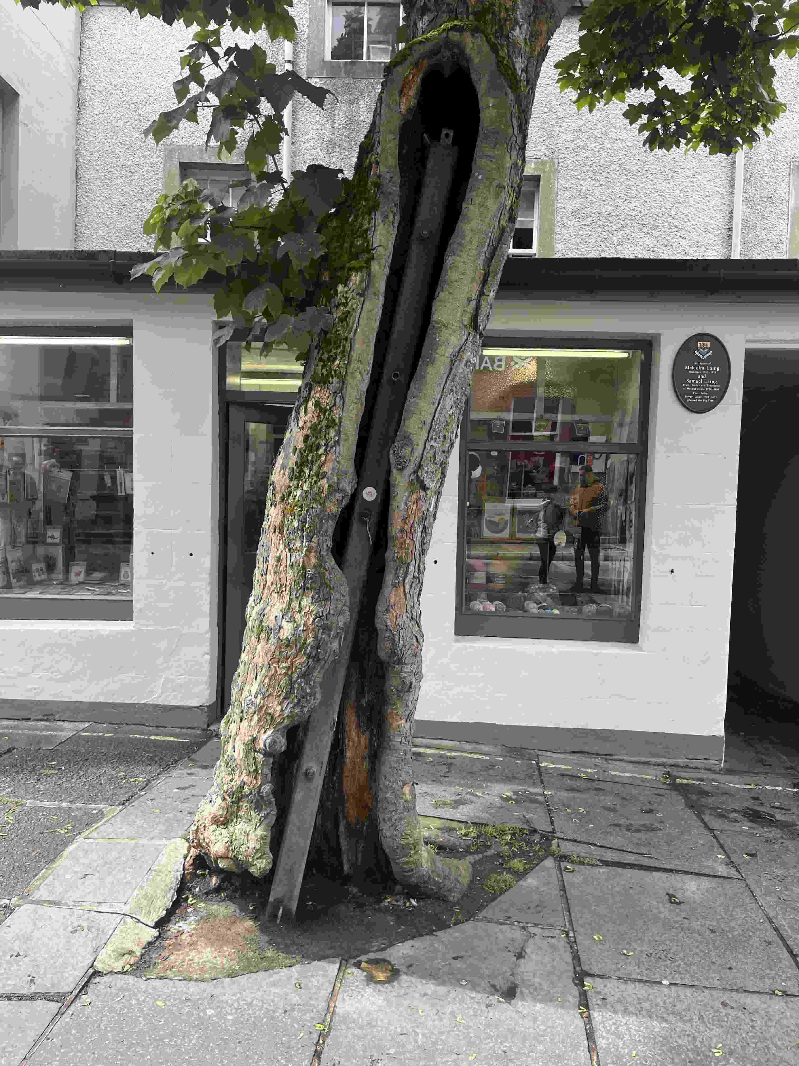Figure 1: Laing's tree in Kirkwall (photo R Hughes)
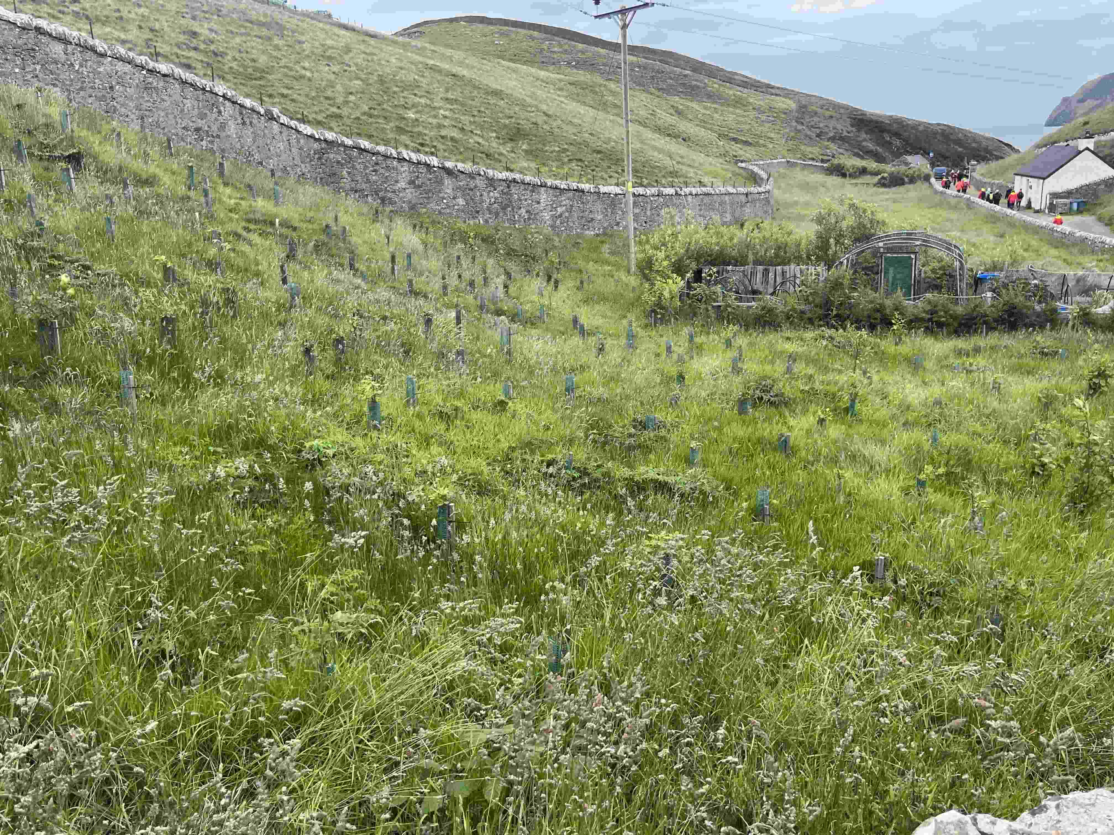Figure 2: Some of the few trees being grown in Shetland (photo R Hughes)

Unst: Britains’ most northerly point, July 2024.
Another Shetland island, with a few stunted fruit trees surviving in vegetable gardens. The only other trees we found were just above Burrafirth beach, a small planting of alder, hazel and oak in the shelter of a narrow walled field probably the remains of allotments for the Muckleflugger shore station cottages above. [2]

Above the beach a road leads to the 965 hectare Hermaness National Nature Reserve, almost impassable land only made walkable by a 7.7 km circular trail on a boardwalk stretching across boggy grass land, a haven for botanists, ending at the cliff top with gannet colonies and puffins almost underfoot on the craggy rocks below.
Angela Hughes. (and many thanks to our roving (international) photographer Roger Hughes, they made it to Iceland [no trees!] (ed)

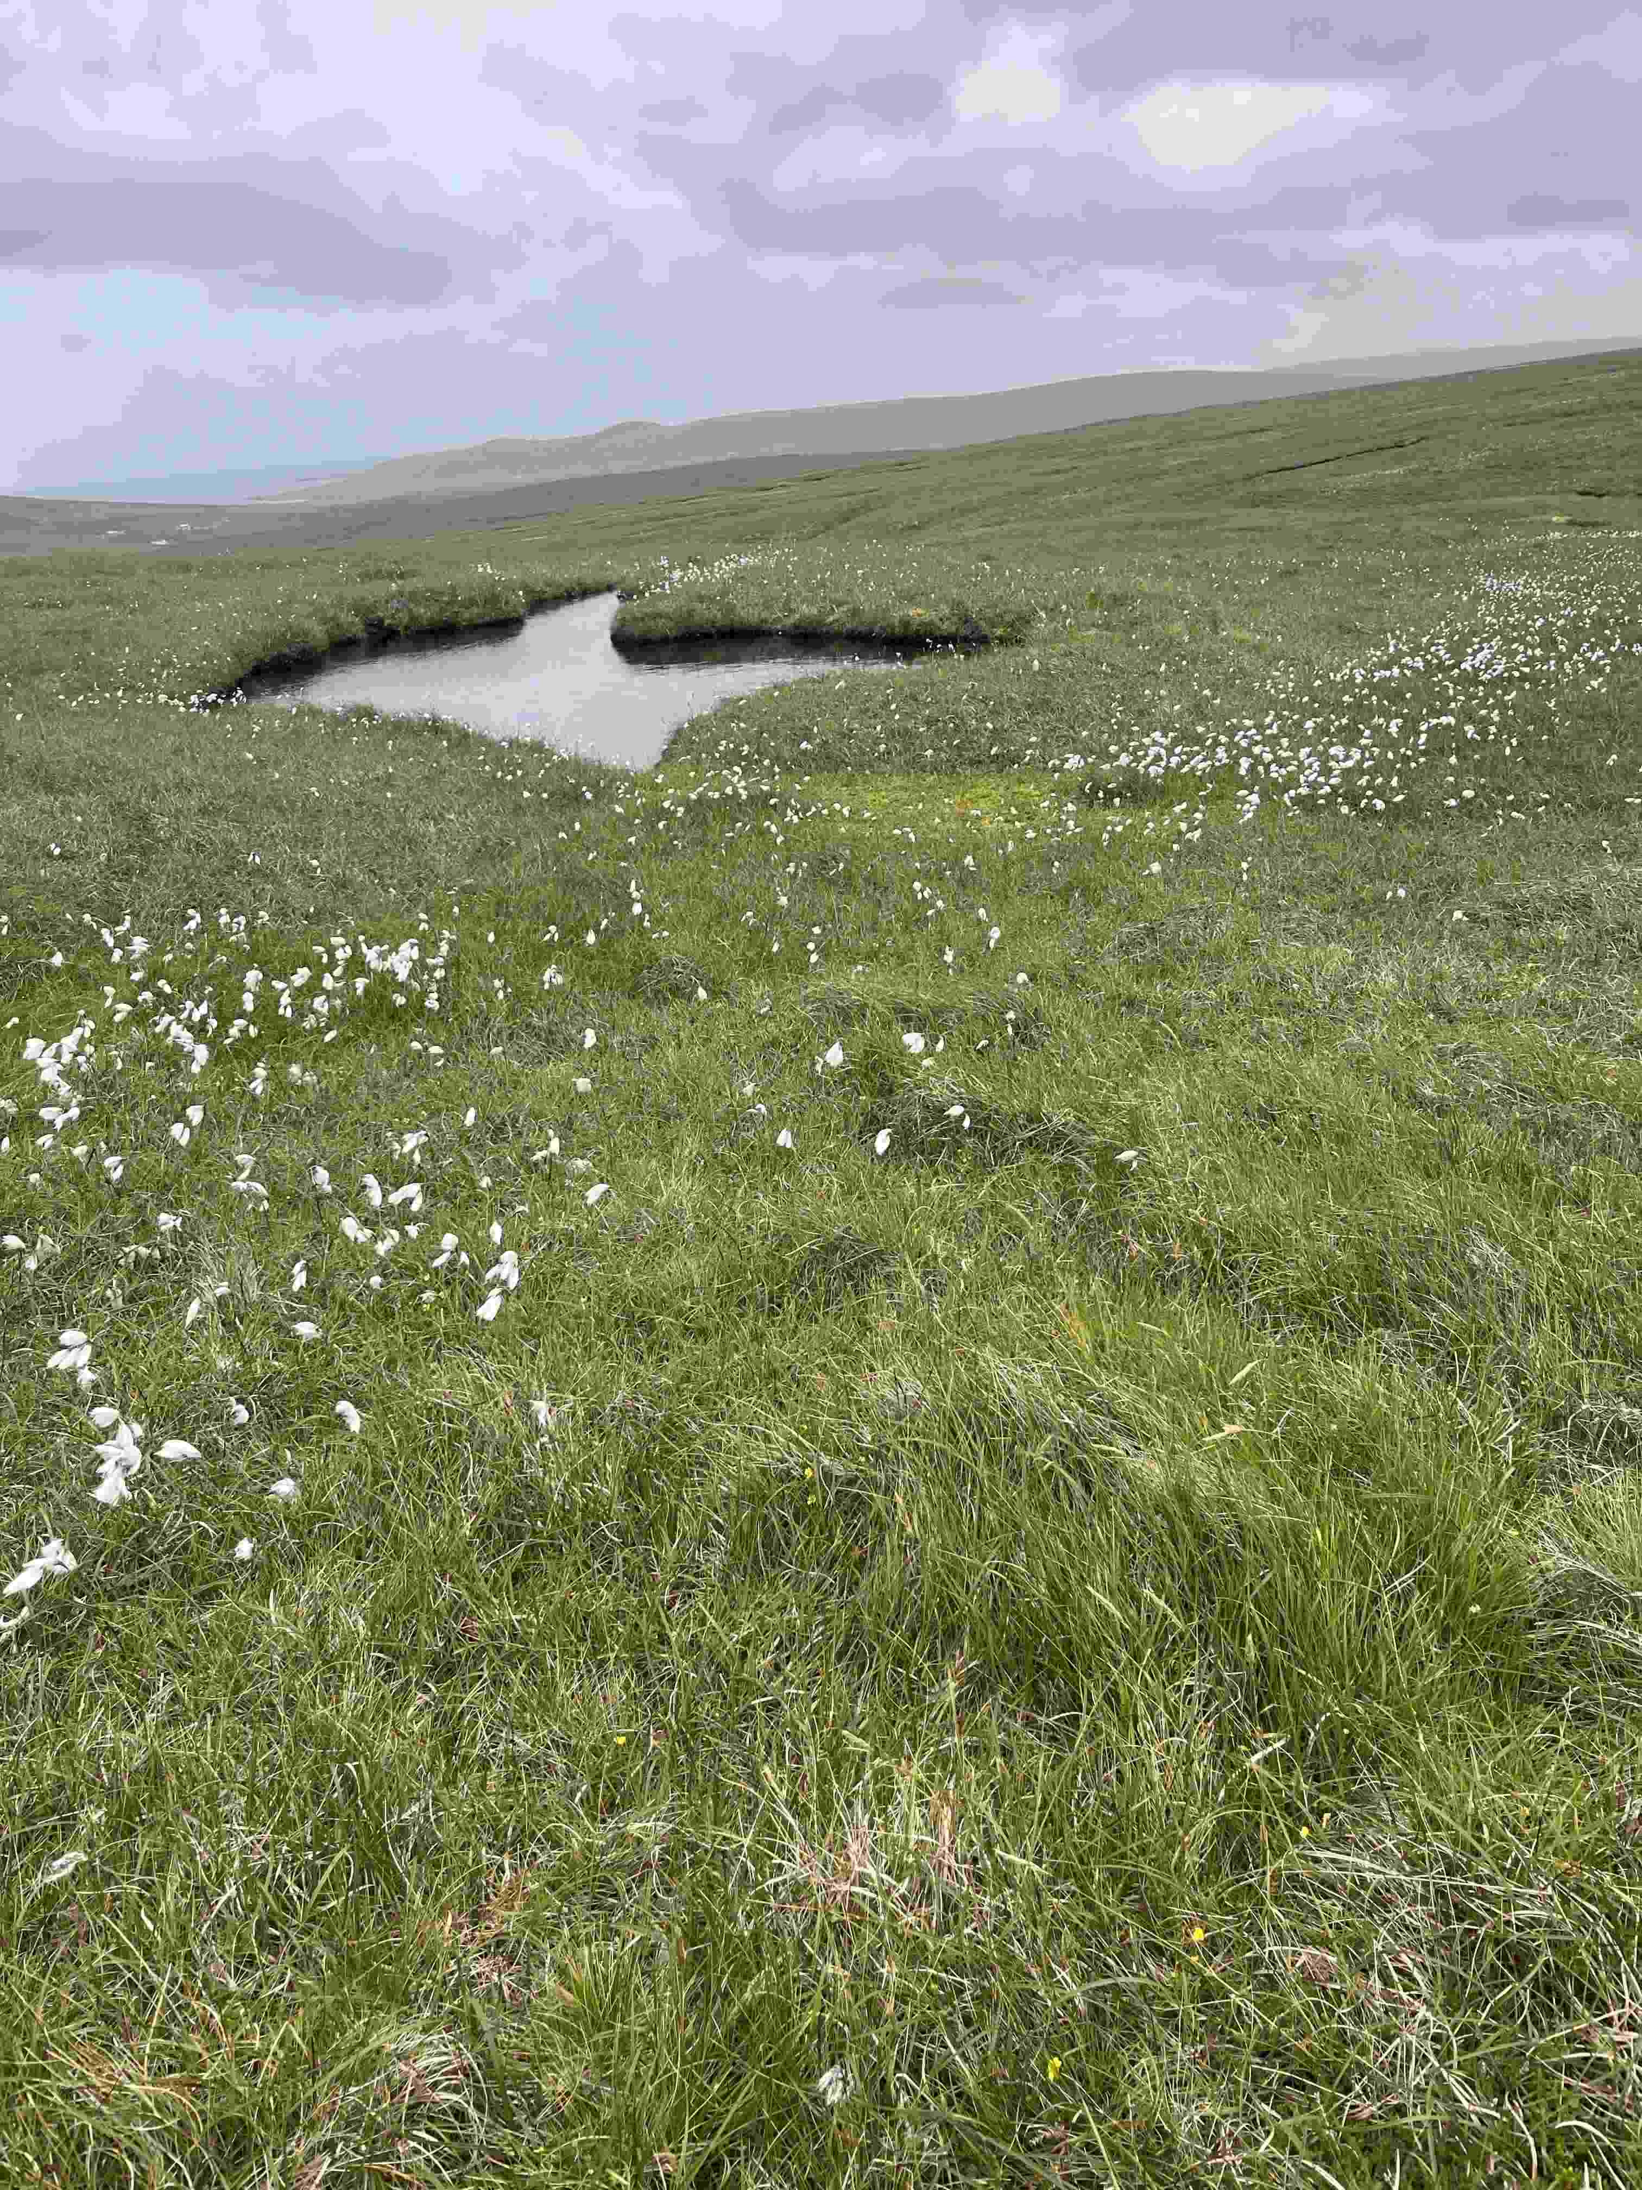Figure 3: Not a tree in sight, typical northern grassland and bog in Shetland (R Hughes)

Appendices; Trees of Ness gardens
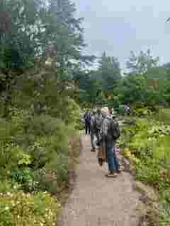Figure 5
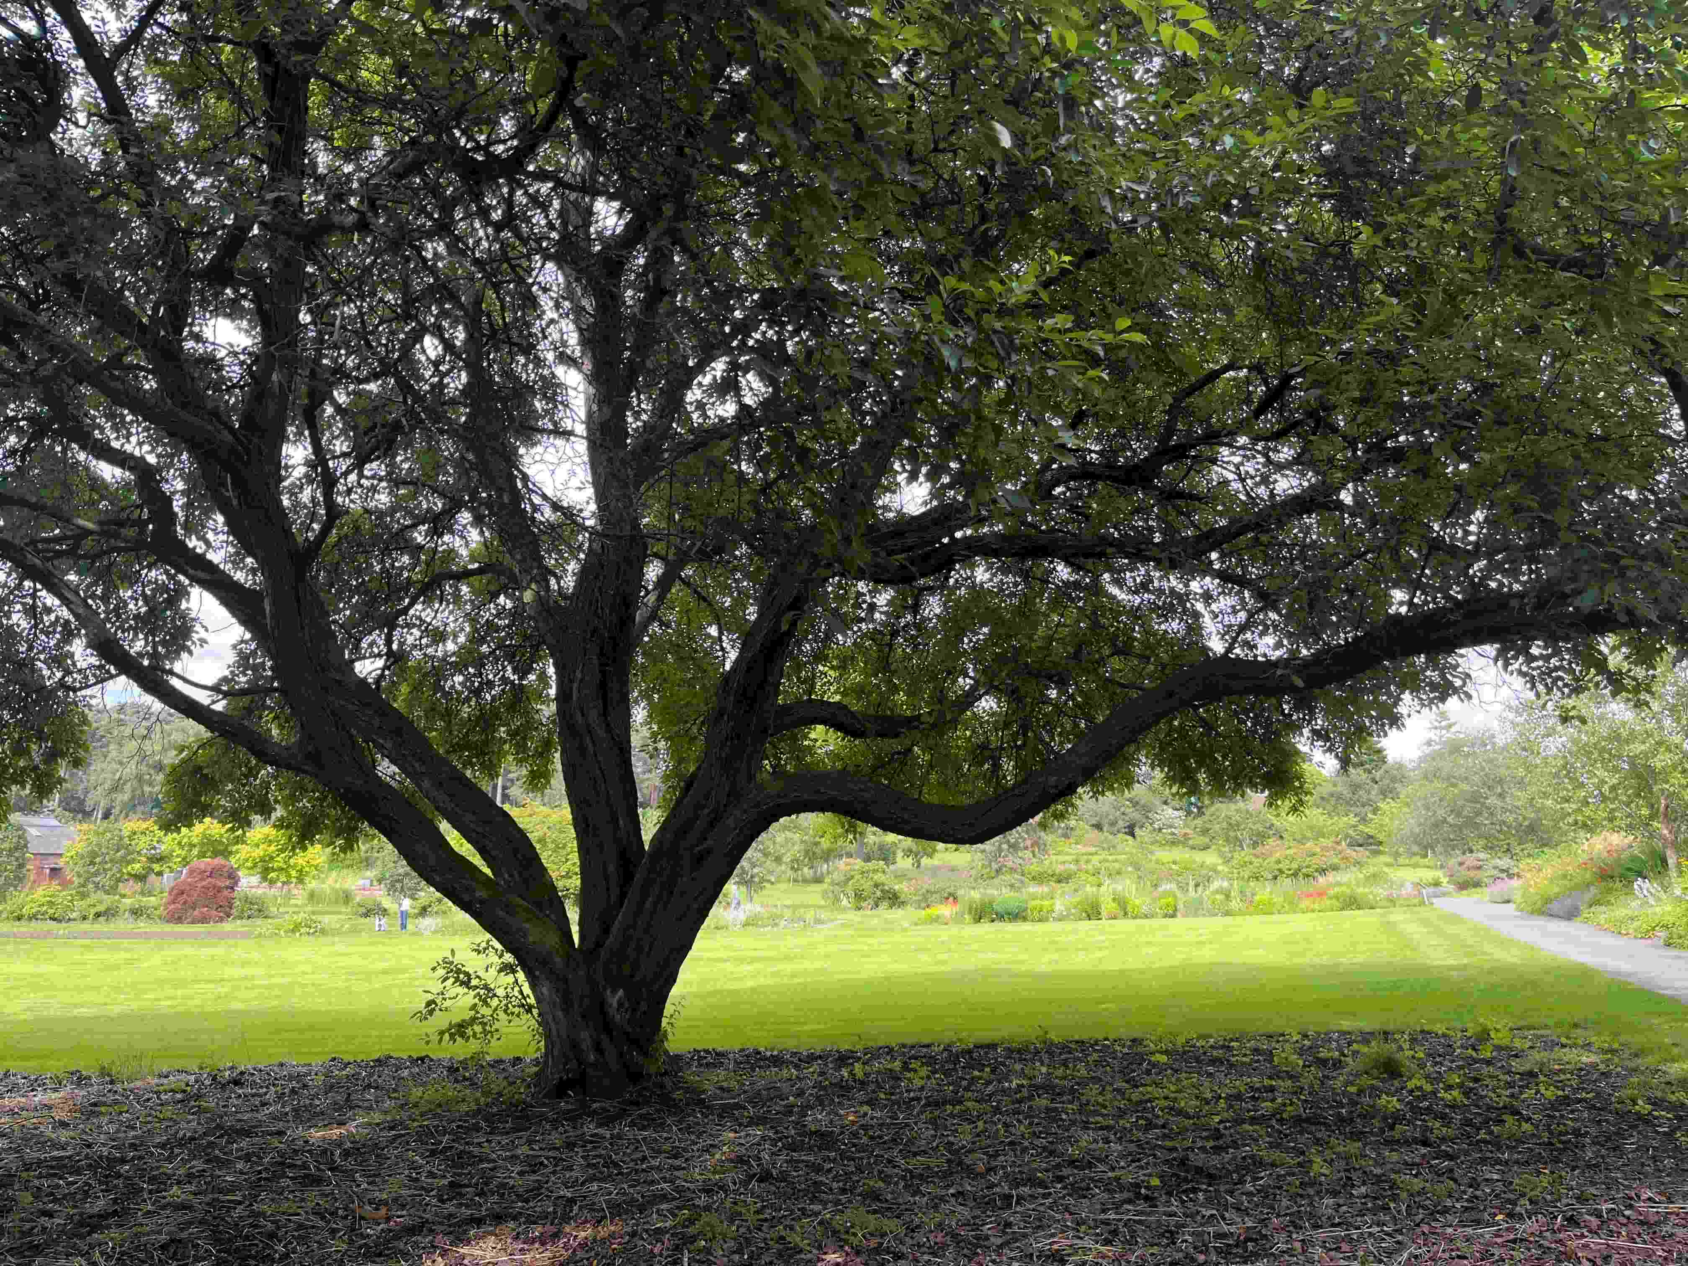Figure 4 a fine specimen of the Hubei Crab (Malus hupehensis) [R Hughes]

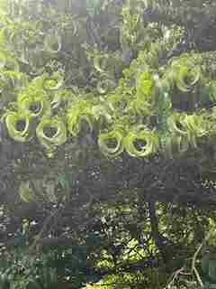Figure 6 the incurved leaves of Heptacodium miconioides [R Hughes]

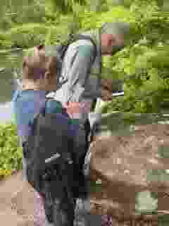Figure 7 The investigations continue. [R Hughes]
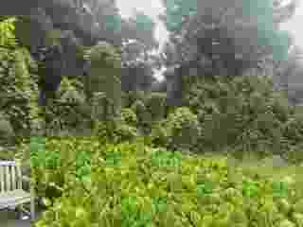Figure 8 a group of young Wollemi Pine (Wollemia nobilis) [R Hughes]
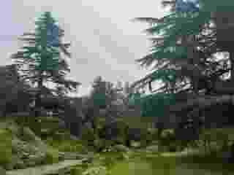Figure 9 Conifers
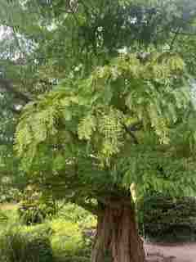Figure 10 a Dawn Redwood (Metasequoia glyptostroboides) with aberrant branch-tip foliage [R Hughes]

