
Visit: Croft Castle Saturday 14th September @ 2pm. Sat Nav HR6 0BL
September 2024

A short newsletter this month, but like ducks paddling, be assured we are working beneath the surface on your behalf (ed).

From the Chair
This is a very busy time of year for me so only a quick note with an intriguing picture (although some people may recognise it).
The ‘tree’ is on display in an equally intriguing and interesting place. No clues but all details in the October newsletter.
Julie Kaye
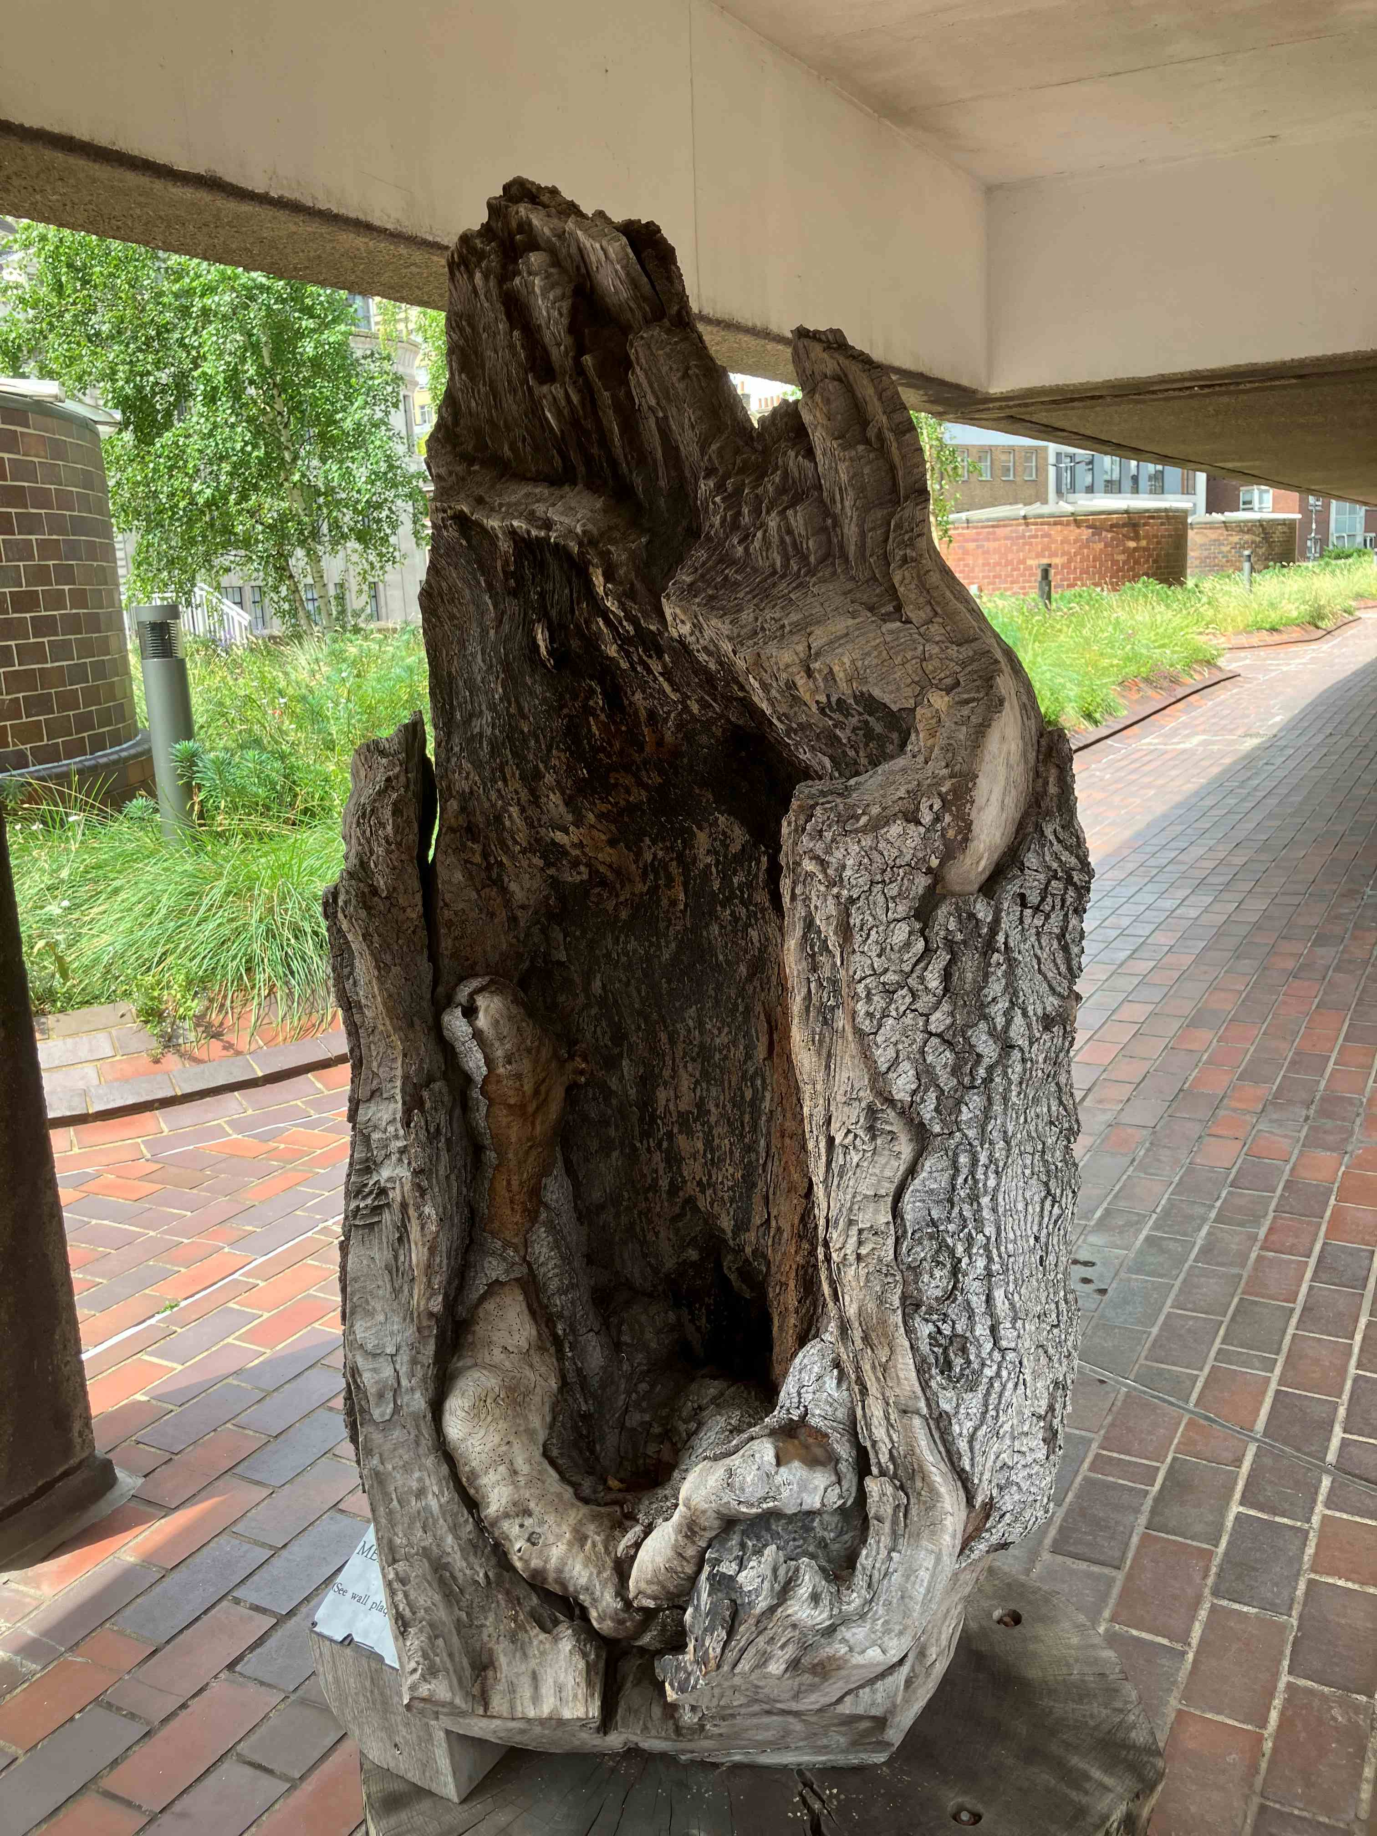Figure 1: Intriguing tree (photo Julie Kaye)

Visit to Croft Castle and Parkland
Saturday 14th September
Meet at 1.45pm in the main car park for a 2.00pm start.

Satnav: use HR6 0BL

Remember to bring your National Trust membership card, or if you are not a member you can pay the entrance fee.
Please think of offering to share a lift with other STT members who live near you.

We shall be given a tour of the trees of Croft Castle estate by Jason Wood, who is the National Trust Area Ranger for Herefordshire.
There is a cafe where you could have lunch before the visit and/or tea afterwards.
You could also tour the interior of the castle before our tour of the estate.

* Croft Castle estate has the largest collection of ancient trees in Western Europe.
* There are some magnificent oaks and other trees in Fishpool Valley, where the lakes have all now been restored.
* Much of the large area of wood pasture on the hilltop was destroyed in the past by the Forestry Commission, but one important area remains. It is the site of the Candelabra Oak. Other areas of damaged wood pasture are being restored – a long-term work in progress.
* The sweet chestnut avenues near the castle are justly famous.
* The Quarry Oak below the castle is also an important tree.
Do join us if you are able.

Picture to go with last month’s article on Ness Gardens
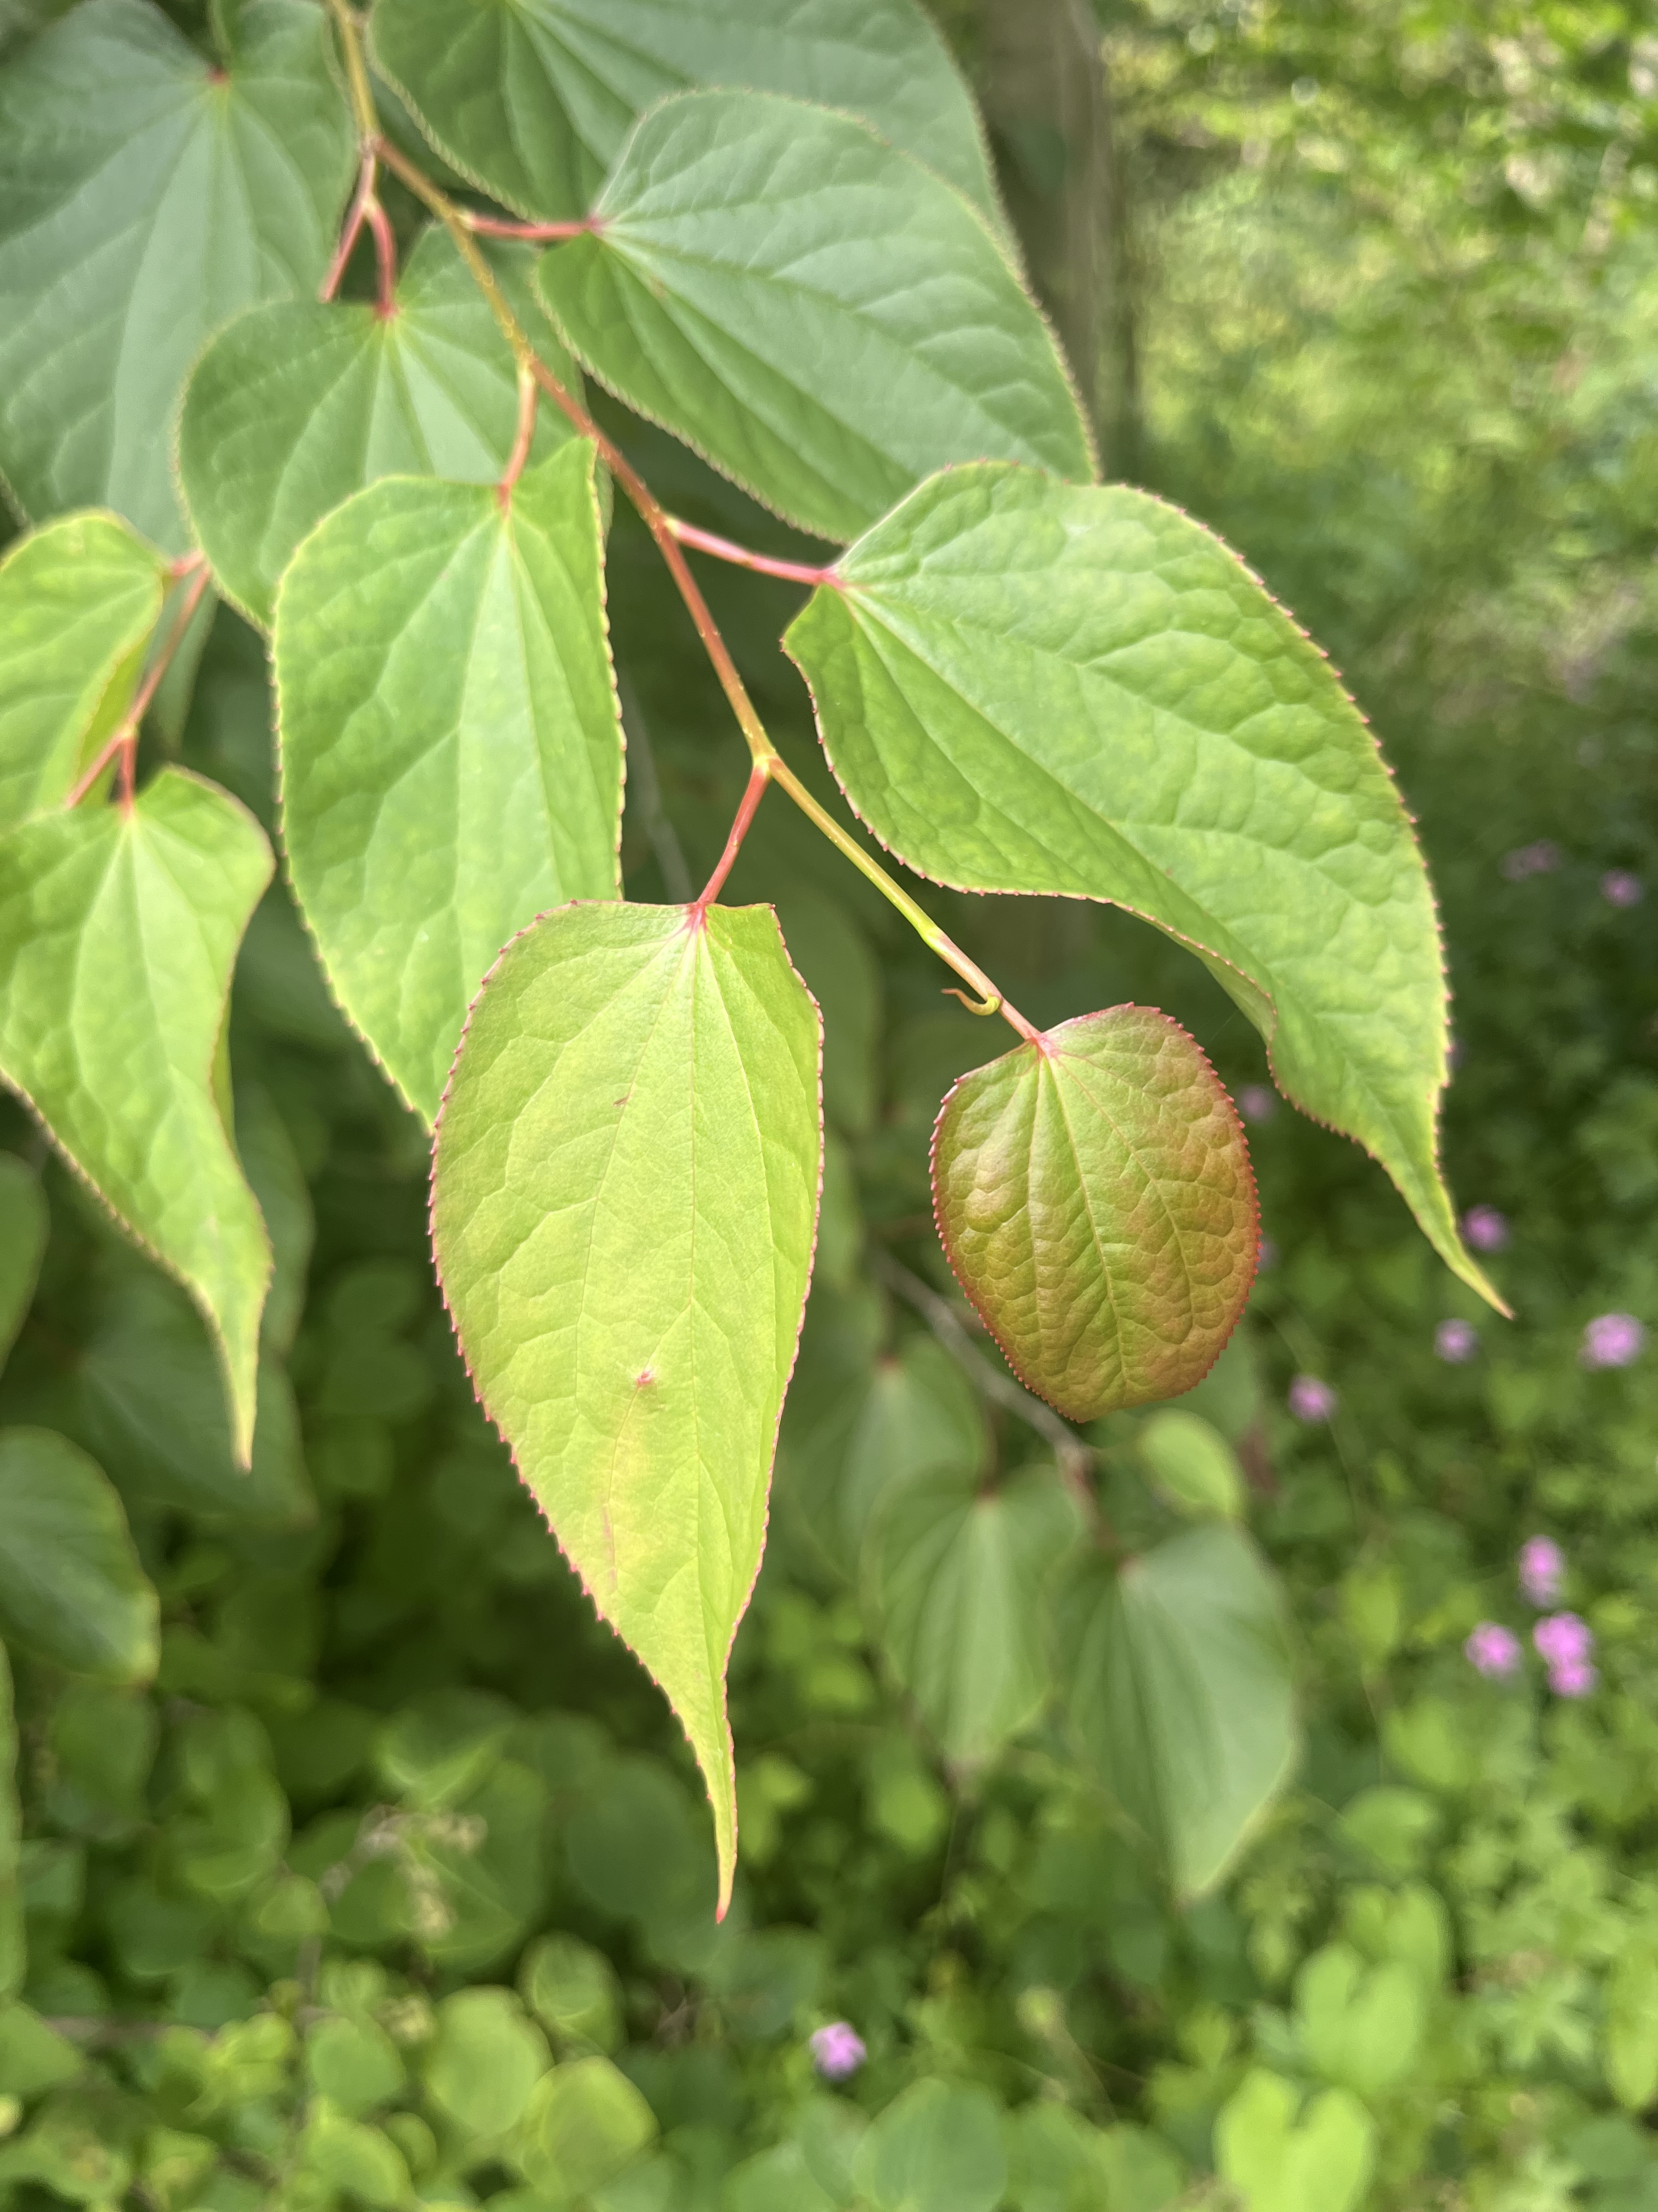Figure 2: Foliage of the Spur Leaf (Tetracentron Sinense) photo G Piearce

