
March 2025
- AGM Tuesday 11th March @ 7pm Shropshire Wildlife Trust

I went paddling recently, not to the beach but down the lane and onto the nearby fields, the dogs were a little less than enthusiastic! The day of heavy rain had turned the paths to slurry and the river Severn had risen by at least 6 feet. Despite this I stopped to chat to a hardy fisherman who had caught nothing but was happy just to sit in the sun and hope!
In common with many people I have grumbled about the spell of wet and windy weather which has wrought such havoc on the trees in places. As yet the deciduous branches were bare, the only interest being the silhouettes.
But trying to be more positive I looked closer and saw the beginnings of bud-break here and there, things were actually looking up and on rounding the corner of a hedge, quite unexpectedly there was a small branch of fully opened blackthorn (Prunus spinosa) blossom, it really cheered me.
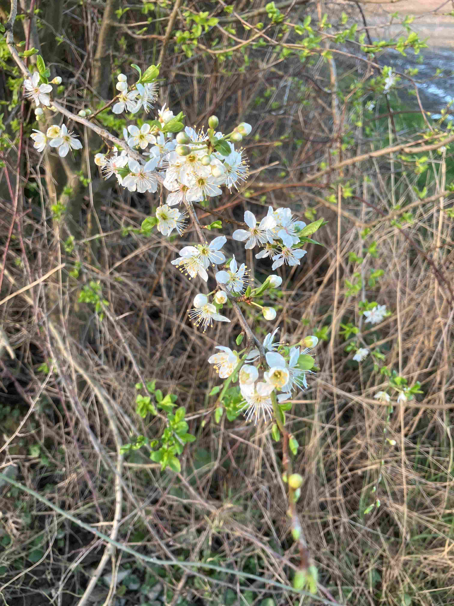Figure 1: Blackthorn blossom (photo J Kaye)
With a blue sky, and much bird-song I walked back through the mud with a lighter step. And the dogs? They still had to suffer a wash down under the hosepipe!

On that more cheerful note I would like to remind you that the STT’s AGM is fast approaching – MARCH 11TH @ 7pm at the Shropshire Wildlife Centre.
I know that AGMs are rarely popular but it is necessary and the Committee hope that we are mostly providing the sort of material that interests you. If not, we need to know what is needed, what you would really like and most importantly how you might help in achieving this.

We always hope that more volunteers are forthcoming, yes to join the committee if possible, but if that’s not your thing are you able to help in any other way? Please speak to a member of the committee if you have any
ideas / thoughts / comments.

Please try to attend the AGM, at least to show your support. Best Wishes in anticipation, Julie Kaye.

STT Programme 2025

March 11th - AGM,

VISITS – 2nd Saturday or Sunday

April 12th or 13th – Arley Arboretum, nr. Bridgnorth (tbc)

May 11th (Sunday) – Visit to David & Jessica Pannet’s garden, Bicton.

June – 14th or 15th - The Isle, Bicton

July 12th or 13th – Vaynor Park, Berriew

AUGUST - NO VISIT

September 13th (Saturday) – Powys Castle – tour with Head Gardener

October 19th (Sunday) – The Leasowes – Cound

November 11th – Talk by Archie Miles Archie Miles' talk in November is - 'Heritage Trees of the Welsh Borders'.
December 9th – no decision

The Fascination of Trees by Richard Gulliver
Richard took us through a number of tree species which he has observed over the years both in domestic gardens, as street trees and other municipal settings. He looked at a number of aspects in considering year-round interest. Look at size, shape, flower colour, scent and support for wildlife.
We were advised to plan ahead for size at maturity but coppicing can help to keep some trees within bounds and, if desperate one could always try Bonsai!

Looking at some tree species and what they can give at different seasons –
Prunus family – flowers in spring; fruits in summer and autumn
Rowan – flowers; fruits which attract waxwings; autumn colour
Japanese crabapple – spring flowers; summer/autumn – fruits
Birch – bark colour – all year interest.
Acers and Liquidamber – autumn colour
Amelanchier – spectacular spring flowering; fruits in summer beloved by blackbirds, though often hidden by foliage.
All deciduous trees give us an attractive silhouette of branches in the winter months.
Willow-leafed Pear - Pyrus salicifolia – attractive grey leaves, white spring blossom and small but inedible fruits in summer.

Moving on to some larger species –
Gingko biloba - Maidenhair tree – distinctive and attractive leaves said to be reminiscent of Oriental ladies with hair flowing down their backs. Gingkos are associated with Japanese temples but have been successfully planted in many parks and domestic gardens worldwide.
Wellingtonia – Sequoiadendron giganteum. These magnificent trees have long held a fascination, especially with children, due to their thick, soft bark which accepts much ‘abuse’ from being punched without damage to tree or child.
They are often found in areas with a high fire risk but the bark, a good insulator, can protect the tree from excessive damage.
The Wellingtonia, along with the Coast Redwood - Sequoia sempervirens, have the ability to regrow.
The Tree Creeper, with its long slender beak, is one of few birds able to obtain insects from within the thick, fibrous, deeply fissured bark
They rarely blow down despite their shallow root plate and so are amongst the most long lived of conifers.

Richard mentioned how some trees can be managed by pollarding or coppicing. Choosing an appropriate species either method can be a means of creating an ornamental tree. In addition a tree may live longer as it may not be affected by wind.

There were also some snippets about the Black Poplar – Populus nigra. The tree has large seeds but the viability is short-lived. Germination was often successful on the bare silty soil left after floods around certain estuaries such as the Dee. Some planted in Manchester appeared to be unaffected by pollution.
One famous Black Poplar is in the village of Aston-on-Clun around which a Festival is held on 25th May when the tree is dressed with flags. The original tree dated from 1500 but sadly fell down in the 1990’s, it was replaced by a sapling from the original tree.

(I must apologise for not including details of the last part of Richard’s talk on the Elm, my notes were very incomplete).
Many thanks to Richard for such a fascinating and informative talk with excellent photograph. Julie Kaye

