
May 2025

Visit to Pannet’s garden: Merton, Shepherds Lane, Bicton, Shrewsbury, SY3 8BT
Shepherds Lane is off the B4380, see below.

Message to members
Have you paid your annual subscription to Severn Tree Trust?
It is of some concern to the committee that out of 80 members on our books, only 51 have paid the annual subscription.
If subs are not paid shortly we will be unable to continue to send the newsletter or any other communication to you.
There are many good visits and speakers planned, it would be a great pity to lose you as a member.
So please check to see if your payment has been overlooked.

Chair’s chat,
Looking at the weather forecast for the next 10 days it’s a timely reminder to keep watering any newly planted trees – which I am sure most of you remember to do – but it often catches me ‘on the hop’. My enthusiasm for buying new and interesting plants does not always extend to maintaining that enthusiasm to get them in the ground – sound familiar?
As a specialist tree group we naturally look to plant trees first in any garden situation knowing, as we do, all the advantages in doing that. I decided to look at the Chelsea Flower Show preview to see if any of the design wizards had opted to try and ‘do something different’ and design a garden without any trees at all and rely on shrubs only. I thought it highly unlikely, and sure enough all the major contestants have incorporated trees somewhere in their design. I did wonder what criteria Monty Don had for his design for the RHS & Radio2 Dog Garden – I’ll leave that to your imagination – answers on a postcard please!!
Time for 2 reminders – 1. so far, no-one has volunteered to help on an STT stand at the Green Fair (see the April n/letter), which is a pity as it would be a good opportunity for our organisation. If you could help please let me know – email, jkaye0848@gmail.com
2. Our next meeting is a visit to David & Jessica Pannet’s garden in Bicton. There are some very interesting trees, planted by the Pannets over a number of years.
This is scheduled for Sunday May 11th. Tea and cake provided.
If you require any details it would be best to email me, if possible leave a contact number so that I can get back to you.
An excellent visit to Arley Arboretum earlier this month, good to see so many members attending. Many thanks to John Tuer for another terrific in depth report on the visit. Best Wishes Julie Kaye
Visit Sunday 11th May @ 2pm
David and Jessica Pannett - Merton, Shepherds Lane, Bicton, Shrewsbury, SY3 8BT
Shepherds Lane is off the B4380, Shrewsbury to Montford Bridge road.
Small crossroads approx half mile after Shelton water tower, near 4Crosses garage.
Approach from Shrewsbury, turn left, approach from Montford Bridge, turn right onto Shepherds Lane.
Driveway to the Pannets' is first right after the private shop and 9 properties. Hopefully there will be some STT signs!
Go up the drive (quite long) parking by the house or on the drive
Tea and Cakes will be provided

Our visit to Arley Arboretum: Sunday, 13th April 2025
Sixteen members turned up to tour this excellent arboretum on what turned out to be a mainly dry day. We did have a slight trickle of rain at the end of our visit at which time we were, inevitably, having our cups if tea just outside the tea room but, as we were on the point of leaving anyway, it caused no problem.
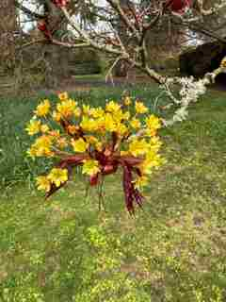Figure 1: Mystery tree at Arley. (Photo Roger Hughes)
I say “this excellent arboretum” because it is just that. This is not a new arboretum and, because its history goes back well into the nineteenth century, many of the trees are tall mature specimens which mingle with newer plantings and trees of a range of ages between.

Angie and I have been here many times and on one occasion I was lucky enough to purchase a very valuable booklet which doesn't appear to be available at present. This is “Hortus Arleyensis II: A catalogue of hardy trees and shrubs”. It has a preface written in 1907 which tells us that this collection of trees was started in 1800 by the Earl of Mountnorris who was a keen tree plantsman and that “the year 1820 has been taken as the approximate date when most of the trees were planted”.

In those days there was an Arley Castle and this takes us to the booklet's second preface written a hundred years later in 2007 in which we are told that the castle was pulled down in 1963 at this time the estate being owned by a Mr. Roger Turner. During his ownership the arboretum was only opened to the puplic on bank holidays each year. Mr. Turner died in 1999 and, since then, it is his Charitable Trust that administers the estate so it is now open on most days

This extraordinary booklet tells us that great pains have always been taken to make sure that all the trees have been identified correctly and it lists all 577 trees with, where possible, their heights and girths in metres presumably measured between 1999 and 2007 although this isn't given. Up to 1907, Sir W. Thistleton-Dyer (Director of Kew Gardens), Dr.A. Henry, Mr. H.W. Elwes and Mr.W.J. Bean were responsible for the identifications. Some of you will recognise these names, particularly Elwes for his books on forestry and Bean for his four volumes of trees and shrubs. More recently and from during the life of Mr. Turner, the 2007 preface gives us seven eminent names of people who have assisted with updating the identifications, including newer plantings. Among these are our friend of the Severn Tree Trust, John Bulmer, who has given us talks on a number of occasions, David Binion who set up and managed his own arboretum at Bodenham not far across the main Kidderminster Road from Arley and Rhoderic Taylor who once guided us around Sir Bernard Lovell's arboretum in Cheshire.

John Bulmer produced his own booklet on this arboretum at the request of Mr. Turner, which was available for a few years but this present Hortus Arleyensis uses the joint identifications including many of the newer plantings.

I am pleased that so much trouble has been taken over identification of all these trees because in my view an arboretum is not just a place to look at pretty and unusual trees but it is also an educational resource. If you have a tree to identify and can take a piece of twig including, perhaps, leaves and flowers or leaves and seeds, and you can match this against a correctly identified specimen then you have your answer. This is where an arboretum with a wide range of trees is invaluable. It is surprising, however, just how many arboreta get one or two specimens incorrectly labelled. So when I go back to what I said about “this excellent arboretum” I can add that not only has so much trouble been taken with the identification of these trees but they are also all labelled. You can't say that for many arboreta either. I don't think we saw a tree that wasn't labelled. We were rushing from tree to tree like children in a toy shop: “What's this one? What's that one?” And we no-where near covered the whole arboretum. There's whole section outside the walled garden to the north of the arboretum that we missed entirely simply because of time restrictions. We missed the maze, too, which was opened about thirteen years ago.

Angie and I distinctly remember going to Arley one May some years ago and going into the Magnolia Garden. Many of the trees were still in blossom, many were shedding their petals. The whole garden was a wonderful sight; white, cream, pink petals everywhere, above us, around us, beneath us on the ground. Of course, timing has to be just right for this but another trip there in May, for anyone who missed this visit or who wishes to return, hit it right and you're in for a treat.

Have you noticed that, apart from a mention of the Magnolia Garden, in this report I haven't named one tree. Well, a report with a bit of a difference this time!

But I must finish with an anecdote. I've mentioned our friend, John Bulmer who, by the way, has his name on the wall of the arboretum listed as a 'distinguished botanist'. His working life was spent as an orthopaedic surgeon but on retirement he took up his interest in trees more seriously and has spent a lot of time grafting trees. He once told us that now, when he sees blood, he knows it to be his own! John Tuer

A small wasp at work on Haughmond
On the south margin of Haughmond Hill the oaks are infested with 100s of these oak apples. Do they inhibit leaf growth, or are they benign?
I trust you would know what they are or would like to know.

Living up to its name, the oak apple gall wasp produces growths, or 'galls', on oak twigs that look like little apples. Inside the gall, the larvae of the wasp feed on the host tissues, but cause little damage. They are described Scientifically as Biorhiza pallida and can be seen from May to June

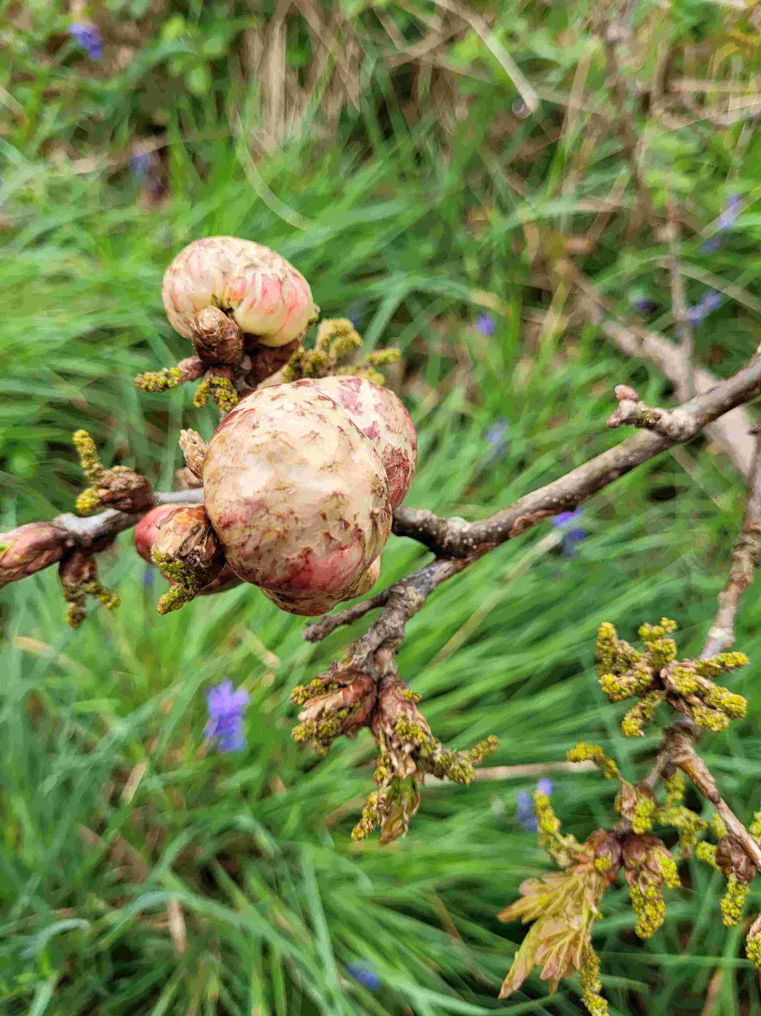
There's a recipe for making ink from them with the following ingredients;

Iron sulphate
Gum Arabic
Oak Apple
Water

Talking of beneficial wasps the editor’s museum is making use of mini wasps and pheromone traps to fight a small invasion of clothes moths in the stores, much better than using chemicals, and cheaper, see on the internet under the brandname of Dragonfli. (ed)

A leylandii by any other name....
What has been described as our most planted and most hated garden tree is familiarly known to us all as Leyland Cypress or simply Leylandii. It arose in Britain in the 1880s as a cross between two North American conifers, so its scientific naming has depended on that of its parents: Monterey Cypress, from California, has long been known as Cupressus macrocarpa and Nootka Cypress, from Alaska, has been Chamaecyparis nootkatensis or latterly Xanthocyparis nootkatensis; hence their intergeneric hybrid has most usually been designated x Cuprocyparis leylandii or x Cupressocyparis leylandii.
However, as a result of increasingly detailed molecular analysis over the past 20 years or so and much debate among conifer taxonomists, those names have had to be revised. It is a long and complex story, but the upshot is that Monterey Cypress is now Hesperocyparis macrocarpa and Nootka Cypress is Callitropsis nootkatensis, and so the modern name for Leyland Cypress has become x Hesperotropsis leylandii.
How long those new names will persist remains to be seen, but the hybrid tree will surely always be known to most of us as Leylandii or Leyland Cypress, whether or not we continue to regard it as a beauty or a beast.
Graham Piearce

THE SEVERN TREE TRUST – Membership Renewal 2025

To renew your membership by cheque, please complete the following and send it to our Treasurer.

John Tuer, Evergreen, 5 Woodside, Homer, Much Wenlock, TF13 6NQ

(please tick as appropriate)
Single Adult membership (£15) ______ Under 21s Membership (£5)________

Double Adult Membership (£20)__________

Title (Mr.) (Mrs.) (Ms.) (Miss) (Dr.)

Name(s)____________________________________________________________________________________________________________________________

__________________________________________________________________

Please confirm your email address.

____________________________________

Address
____________________________________________________________________________________________________________________________________

____________________________________________________________________________________________________________________________________

Receipt of newsletter. If possible we would like to send you the newsletter by email as it saves on postal costs. However our editor will post it to you if you have no email access.

The newsletter is always available on the website https://severntreetrust.co.uk

Thank you for renewing your membership.
We look forward to seeing you at our meetings.

