
- Visit: Hodnet Hall gardens visit, 13th July 2025 @2pm
July 2025

From the chair,
We thank you for your continued support and hope to see many of you at the Hodnet visit. Julie Kaye

Hodnet Hall gardens visit, 13th July 2025 @2pm
The visit to Hodnet Hall takes place on Sunday 13th July at 2pm. For those members who possess Gardeners World Two-for-the price of one cards, they are most definitely valid. The farm here, The Hollies, is only ten minutes away and so any members who would like to bring a packed lunch beforehand, they would be most welcome at anytime after 11am. Faith and I can provide brews and loos. We are very close to Weston-under-Redcastle and the road between that village and Hodnet via the entrance to Hawkstone Follies is known locally as Paradise (for even more obvious reasons when bluebells are in flower). Please let us know beforehand if you intend to arrive in the morning: contacts silvaspinpeter@aol.com, 01948840073, SY4 5RT. Thank you.

Some of you will remember the tour of Shrewsbury’s trees last summer. STT have been asked by the Green Party if we could lead a similar tour the previous day (12th July). However, this will be slightly different in that it will not just be a description of the arboreal landscape but also a critique and suggesting ideas of how to improve it. The Greens are charging £5 per head and have offered to split the monies 50/50 with STT. Hopefully an interesting couple of hours. Peter Aspin

The Green Fair, Shrewsbury Saturday 28 June
Angie and John had an interesting day at the Green Fair in Shrewsbury. It was a pity that it coincided with Shrewsbury's Food Fair but plenty of people came along in the morning; not so many in the afternoon.
We had a lot of interest in our stall. Thanks to Johanne for the Tree Trail booklets. They attracted a lot of interest too. I also took the rest of our "Dendrology Books" - some years ago we bought 10 from Merelene Davies when the magazine, The Dendrologist folded up. We still have a few left. We'd been selling those at £1 each. John Tuer

Report on our visit to The Isle Farm, Wednesday, 18th June 2025.

This was an unusual visit on two counts. Firstly it was during mid-week when our spring and summer visits are usually at weekends and, secondly, there weren't as many interesting trees, this being a farm and the farm owner, Edward Tate, devoted his time to telling us about the many environmental ways in which his farm is being run.

So on the first count, although mid-week, the visit did draw 16 members along on a superb afternoon weather-wise, on the second, an insight into the running of the farm was fascinating information-wise and there were sufficient interesting trees for those who were solely tree-devoted to have made the visit worthwhile for them too.

There was some discussion over a number of the trees. No-one demurred from the view that there was a Turkey Oak, a Pin Oak, a Persian Ironwood and some Junipers, but debate was whether or not a cedar was a Deodar or a Lebanon Cedar and whether or not an Elm was an English Elm. Richard, who was with us, is currently undertaking a study of the Elm Tree so he took some leaf and twig samples and, perhaps, in a later Newsletter will let us know what he thinks.

We moved towards the large lake in the centre of the farm estate and, in doing so, passed through a woodland of tall trees of both broad-leaved deciduous and conifer species.
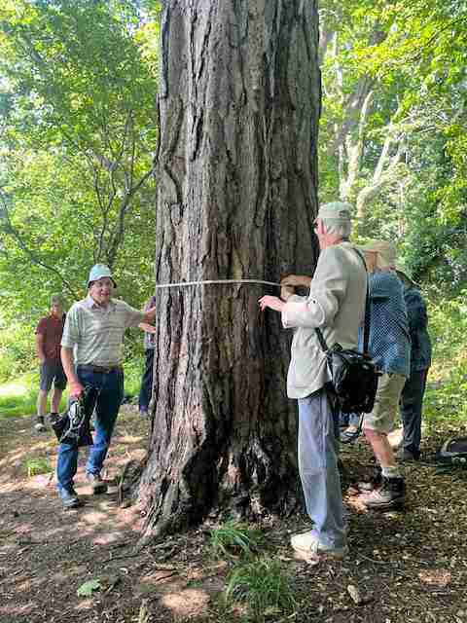Figure 1: The Isle; measuring the girth of an Scots Pine (photo R and A Hughes)

A word about the lake first though. This is thought to be a kettle hole, formed as the Ice Age was receding. Deposits of ice would sometimes be left standing in deep moraine. When the ice melted, there would be a hole left which would fill up with water; hence a kettle hole and a kettle hole lake. Don't ask me why the word 'kettle' is used to describe them but this one, here at The Isle, the farm's 'waterman' told us, is home to a rare strain of carp. NB the west of Shrewsbury and of course Ellesmere are both dominated by kettle holes [ed]. When Edward turned up to join us, he told us that at the far side from where we were, a number of rare Dragon Flies were breeding – the Norfolk Hawker.

So what was in the wood around the lake? There were tall two-needled pines which we agreed to be Corsican Pines. These had grown up rapidly towards the light so had put on a greater height than girth. There were Robinias and as these often start from one original tree, there was the 'mother' tree with others around it. Is this from layering, suckering or, simply, seedling? Could anyone tell me please? There didn't appear to be any evidence of layering however.

There were some oaks. We didn't investigate which species because some of us, as they were so tall, were more concerned with measuring their girths. Again, they were surrounded by other trees and had shot up towards the light, gaining height at the expense of girth so their girth would belie their age. Oaks are not really a forest tree although they have been grown in plantations to obtain long lengths of timber for woodworking. They are, naturally, an open-grown tree and, as such, their usual form is one of spreading by starting branching out low down. Let me describe what Richard St. Barbe Baker says about the oak: “Among British people the sovereignty of the oak is not disputed. Virgil noted its chief characteristics, longevity, firmness, the sturdiness of its limbs, the twisting of its branches, their expansive spread. Splendid in form and of great usefulness, it has always been regarded as the glory of the forest”. I state this because there's a contradiction here. When grown in a forest, it is the forests' glory, but in that situation it wouldn't be spreading. I think St. Barbe was being a bit 'poetic' here. By the way, Richard, St. Barbe Baker, who is he?

Look at the top of the front of this Newsletter. Now look at our website.

There were some Horse Chestnuts which were being attacked by the leaf miner, Camareria Ohridella. This is so common on Horse Chestnut leaves these days but it doesn't appear to kill the trees.
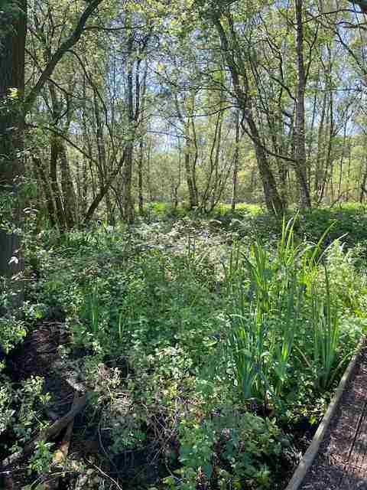Figure 2: Undergrowth and Birch trees at the Isle (photo R and A Hughes)

We moved back towards the farm house where Edward showed us two interesting trees: firstly a Tulip Tree in flower with many buds yet still to open. This is a very beautiful tree when it reaches flowering age. Secondly, he showed us a large spreading, yes spreading because not immediately surrounded by other trees, English Oak that was planted for King Edward VIII's accession in 1936. This must be very rare. How many of us have seen anything to commemorate this king who didn't reign more than a year?

As we walked back to our cars, there was a heavy scent in the air. And there it was, a Privet hedge in full flower.

Thank you Edward for an excellent visit. He has invited us back again should we wish to see more of the Isle Estate. I think we shall be taking him up on that. John Tuer

An unusual Scottish garden
Logan Gardens at the Rhinns of Galloway is a place I’m sure many of you have visited and remember with affection, even awe. Established in 1869, now belonging to Edinburgh Botanic Gardens, they cover 15 acres.
Exotic is the adjective most applied in descriptions of the gardens. Conservation is the main aim as they protect many species threatened in the wild. Sheltered by high walls and established trees on a narrow peninsula pointing out towards the Gulfstream, the mild climate allows the survival of many plants which would succumb elsewhere in the UK. Unfortunately I did not take copious notes, easy to do as the myriad of trees, shrubs and perennial flowers are reliably labelled. The walled garden, overlooked by the Tea Room, is formal with a pond and much to see. There are Tasmanian and Australasian areas, hence many eucalyptus and tree ferns, a Chilean section, a Wollemi pine, Wollemia nobilis, planted in 2006 grows 60 cms a year, a Sorbus madeiriensis is particularly rare, giant Gunnera, there is a huge variety of trees and shrubs.
The drive in is an avenue of Chusan palms, Trachycarpus fortunei, a little windblown this year. In mid May only the late rhododendrons were still in flower, the magnolias were over but it was the sheer abundance of unusual plants which enchanted, Olearias with not a leaf showing a mass of white flowers, an Embothrium coccineum in full glory was a sight to behold. There’s a Champion filo pastry tree, Polylepis australis which comes from high altitudes in the Andes, the thick peeling bark explaining its nickname and also the insulation which ensures its survival against cold and fire. A dramatic Sophora, denudata I think, was a stunning display in full bloom
The glass house contained a large collection of pelargoniums and South African specialities. Joanne Bracchi

Out on a limb, unless you are travelling to Northern Ireland, Galloway with its RSPB reserves, early Christian history and remains and splendid coastline is a very interesting place.

PS a small number of members who receive a real mail newsletter did not receive last month’s newsletter. Apologies; the editor was on holiday. [ed]

Sayings;

This might appeal to our members as the Severn is not just an English river or we just an English group.

The saying in Welsh dod yn ol at fy nghoed, with its impressive mutation, meaning to ‘come back to my trees’ is used to express relax and unwind, to calm down.

Best wishes or dymuniadau gorau,
Johanne Bracchi

