
Visit- Saturday 13th September to NT Powis Castle, Welshpool, Powys. SY21 8RF @2pm.
August 2025

Dear Member,
I am fascinated by connections and fond of a tipple of gin & tonic on a Sunday. Most people will know of the connection between Gin and a tree, but what and how many connections are there?
Here are some connections – Juniper; mother’s ruin; Dutch courage; gin palace.
1. Juniper – a small, coniferous tree, the small cones of which are used to flavour a liquor made from distilled, malted barley. The drink ‘Jenever’, Dutch for juniper, gave Gin its name.
2. Dutch Courage – gained by soldiers when they drank gin before a battle. [not a particularly PC use for Dutch people, forgive us this purely literary reference. ed]
3. Mother’s Ruin – when the Gin craze hit London people would sell anything they could find to get money to buy Gin. One infamous case in the 18th century, was Judith Dufour who murdered her infant daughter, sold the new clothes the child had been given in order to buy gin!
4. Gin Palace – in the 1750s the craze for gin mostly died out due to legislation, poor grain harvests leading to increases in price for grain. There was a revival of the popularity of gin in the 19th century, sold in up-market hotels and pubs or even private yachts, giving rise to the expression ‘gin palace’ for anything flashy.
It is worth noting that in the 18th century Gin was twice as strong as it is now and was drunk by the pint!
The flavour of the juniper berries masked the bitter taste of quinine in tonic water and quinine was used to help defeat malaria, so G&T’s became very popular in the British Empire!
We now have a big revival of specialist Gins each with its own unique flavour and the drink is once again very ‘in’. Cheers!

Could I put out a request to members to offer to lead future visits, especially if you have any arboreal qualifications or, at least, a keen interest and possibly a willingness to do a little research. Not wishing to put anyone off but just a little guidance and a contact point would be very helpful. Please think about it, it would not be a regular commitment.
Hope to see you soon.
Julie
]
Green Party tour of Shrewsbury, July 12th 2025
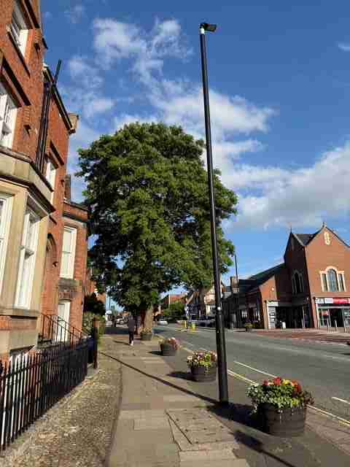Figure 1: Tree of Heaven, Abbey Foregate (photo Peter Hughes)

On a very warm day we took a group of Green Party members through Shrewsbury partially following STT’s Tree Walk leaflet. They had asked us to begin at the Abbey and end at the Quarry so the first trees we looked at were two of the most dangerous ones in town: the huge Ailanthus Altissima (Tree of Heaven) growing out of the tarmac and pavement between the Abbey and The Shirehall which when it inevitably falls will probably damage every utility connection nearby, so notorious is it for suckering over a large area, and a massive oak in the Abbey grounds which was last pollarded too many decades ago with one of its huge limbs having been dead for years and ready to drop on an unsuspecting dog owner at any time- we accidentally discovered that the grounds were a favourite place for walkers who did not pick up.
Taking note of a number of healthy and sickly trees as we walked towards town we ventured into the wonderfully peaceful Abbey Gardens with the extremely tall Ginkgo Biloba partially hidden in one corner and the hybrid Black Poplar adjacent to the Severn towering over everything else. There is a matching one in the smaller garden across Abbey Foregate and just upstream. Surprisingly no one seemed to know about this garden which can also be accessed by scrambling under the arch of the English Bridge when the river level is low. In both the Abbey Garden and grounds there are a pair of miserable looking Nothofagus Antartica (Southern Beech) of no great age which have never been managed in any significant manner.
We walked up the Cop noting the weird collection of hollies in St. Julian’s churchyard (sometimes mismanagement can have interesting results), this writer’s favourite garden at St. Julian’s old cemetery (the gate sadly padlocked) and onto the top of Pride Hill and its unfortunate London Planes- what a lack of opportunity and why only two. Presumably a third died. The heat was getting more intense and we were doing everything we could to stay in the shade. About the turn of the millennium, STT (or rather the predecessor International Tree Foundation) planted four trees in The Square with the then mayor’s assistance and how they would by now have altered the appearance of the place. Unfortunately, they did not last long before being ripped out by council workers, possibly following a mayoral change. I can’t recall.
We visited Old St. Chad’s churchyard which is one of the best managed spaces in town and always a delight to enter. Apart from one very poor young conifer which badly needs removing all the trees here are really well looked after and lots of light reaches the ground. Similarly when we visited new St. Chad’s where the dominant Deodar has had all the lower limbs removed to let light down to the under-storey. Sadly, the most fascinating tree here, the Maackia Amurensis in the farthest corner from the church, which was so healthy last autumn had disappeared by this spring, apart from a stump. An act of God, or perhaps chainsaw, I know not which.
The tour ended at the top of the Quarry where I mentioned that all the Large-leaved Limes therein had been removed in 1949 as they were too old and dangerous and they were replaced by hybrid limes (largely) soon afterwards. These are now seventy years old and so enjoy them as they reach their peak. Imagine what a kerfuffle there would be now if they were taken down. Despite the weather The Green Party enjoyed the walk and some commented that they would look at Shrewsbury from a very different viewpoint in the future.
The mention of the Ailanthus and Limes removal were taken from Andrew Morton’s important book “The Trees of Shropshire” published in 1986. Inside is an intriguing dedication “To the memory of Di Moss”. One of the group introduced herself and said she was this lady’s daughter and her mother had died the year before publication. But she never knew the connection. I’ve no idea if Mr. Morton is still alive. Life’s rich pageant. Perhaps STT should revisit some of those trees in 2026.
Peter Aspin

Powis Castle visit on Saturday 13th September at 2pm.

Powis Castle, Welshpool, Powys. Wales. SY21 8RF
Off the A483 Welshpool to Newtown road.
About a mile South of Welshpool follow brown tourist signs to Powis Castle on your right. Please note it’s a one way system once in the park.

Please note there is a 5-10 minute walk allowing time to pay or show your NT cards at the Car Park Ticket office first. Meet at the picnic tables near the Garden Entrance.

Our visit to Powis Castle takes place on a Saturday this month, September 13th.
National Trust members have free admission, otherwise normal prices apply, £15 per person or £16.50 with Gift Aid.

The tour will be led by David Swanton, the Head Gardener, or by one of the gardeners should he be unavailable. We hope to have copies of their maps of the ‘Trees at Powis’, particularly helpful for anyone leaving early so they can spot more trees on their way back!

David plans to meet us all at 2pm by the picnic benches opposite the Garden Ticket Kiosk. Toilets are located at the garden entrance level, underneath the Garden Shop.

Refreshments: The Courtyard cafe’ in the castle with a pop-up ice cream van in the courtyard, and the Garden cafe’, ice cream stall and toilets located in the lower formal gardens.

‘The garden at Powis is considered to be one of the Trust’s finest, with over 26 acres to explore and enjoy. It was conceived in the 1680s for the 1st Marquess of Powis and is one of the few baroque gardens to have survived in more or less its original form. Wander the great Italianate terraces blasted from the solid rock. Marvel at the spectacular 30’ high yew hedge, dancing statues and lavish herbaceous borders.’

Hope to see you there! Angela Hughes

The newsletter is always available on the website https://severntreetrust.co.uk

Thank you for renewing your membership.
We look forward to seeing you at our meetings.

