May 2026

- Visit Bolesworth castle Saturday 9th May. CH3 9JJ @2pm link up with NGS.

- Please remember to renew your membership @ £15 pp
From the chair,
Oakgates nursery in Ellerdine was something of a surprise to those members who had not visited before being an independent and family run business which propagates a good percentage of the plants itself at a reasonable cost avoiding the “middle man”. It also has an excellent café and a couple of well-maintained gardens full of interesting trees and shrubs which the customer is positively encouraged to wander around. This spring has been one of the best for flowering trees such as cherries and magnolias and despite strong winds just before the visit they were holding on to their blossom very well. One spruce with scarlet flowers that particularly took our eye we hopefully identified as Koyama’s Spruce though labelling was not quite as thorough as it had been in the past. Altogether an excellent nursery to visit if in search of material or inspiration, not least because virtually across the road is an old-fashioned rural pub locally known as The Tiddly, aka The Royal Oak.
The intention was to have a guided tour of Nobridge nursery at Waters Upton a few minutes from Oakgates. As this was cancelled we manage to arrange at short notice a real treat, a tour of the gardens at Eyton Hall by the owner/gardener, Kathy Moynes. Some of you will have visited here on the annual charity snowdrop walks but this was a far more informative occasion. On one of those days in merrie England when there were at least four seasons in a day, we were taken all around the grounds and the old pinetum and walled garden and along the recently dredged serpentine lake alongside which trees were being planted as a screen against the ever expanding metropolis of Telford. And here we came across an Egyptian Goose with eight very freshly hatched young which unfortunately scarpered in every direction in panic. We exited very quickly hoping they would reunite without harm and avoid the marauding Canadians. We ended a very interesting afternoon in our host’s kitchen for brew and biscuits and photographs of the hall as a ruin in the sixties. In lieu of payment, STT donated a cheque for the Eyton church and a couple of trees for the screening barrier.
In mid-April Faith and I visited Arley Arboretum as it was a special weekend on the adjacent Severn Valley Railway. On the return journey we stopped off at the NT car park on the left bank of the river at Hampton Loade which must be one of the most underused in the country, at least since the ferry shut down. The remains are still there as is the now near ghost-like sign that affirms that the ferry is “open”. Walking through the village where there has been much new development there was the distinct odour of raw sewage from the stream below. Working in the field here a few days later I was ten yards from the boundary brook when there was a similar not so delicate aroma. The same day I was reading an article in a fortnightly paper about the levels of sewage pumped into the watercourses in the Church Stretton area in the last year or two. (In the same rag there was an article about the corruption and incompetence at Shropshire Council HQ, no wonder council tax is rocketing- why do we have to read about this stuff in the NATIONAL press?). Water levels are as low as I can ever remember in late April so pollution levels owing to lack of dilution are going to be very high and oxygen levels the opposite.

Visit to Bolesworth Castle on Saturday 9th May at 2pm
It is about a decade since STT last visited Bolesworth estate at Tattenhall in South Cheshire. This visit coincides with the day it is open on the National Garden Scheme open day so that facilities and refreshments are available. It is open from 10am to 5pm at a cost of £10 so that if anyone would like to arrive much earlier than a normal STT meeting then they will have more time to explore. Postcode is CH3 9JJ and the normal yellow roadside signs for NGS will be very visible, simply take the A41 northwards from Whitchurch. In the leaflet it describes an uphill walk from the car park provided to the sandstone ridges with stunning views over Liverpool and the Welsh hills.
A mile or two before Bolesworth is the roundabout at Broxton close to which is, or rather was, one of the most fascinating of Victorian tree plantings. Following the construction of the Whitchurch to Chester railway a soft fruit industry developed in the middle reaches of the Dee around Holt and Farndon. Transhipment and storage sheds were built at the railway station to convey the fruit and dairy produce to the urban areas and to help ameliorate summer temperatures a small forest of conifers was planted surrounding the buildings. The railway and the industry and most of the conifers are now long gone although for anyone who enjoyed Oakgates nursery, the centre of the strawberry empire is now an excellent nursery and café owned by the Bellis family. The railway sheds at Broxton became a picnic site and car park but in recent years became notorious for a certain type of activity and have been fenced off for some time.
This has been one of the best springs for extended tree flowering but any that have been planted in the last year are under extreme stress with very dry winds and soils, warm daytime temperatures and cold nights. Stored rainwater is the ideal preference but if none is available grey water will do more good than harm. Anything to keep it out of our watercourses. Peter Aspin.

Figure 1: Storm damage to a Redwood at Eyton Hall (Hughes)

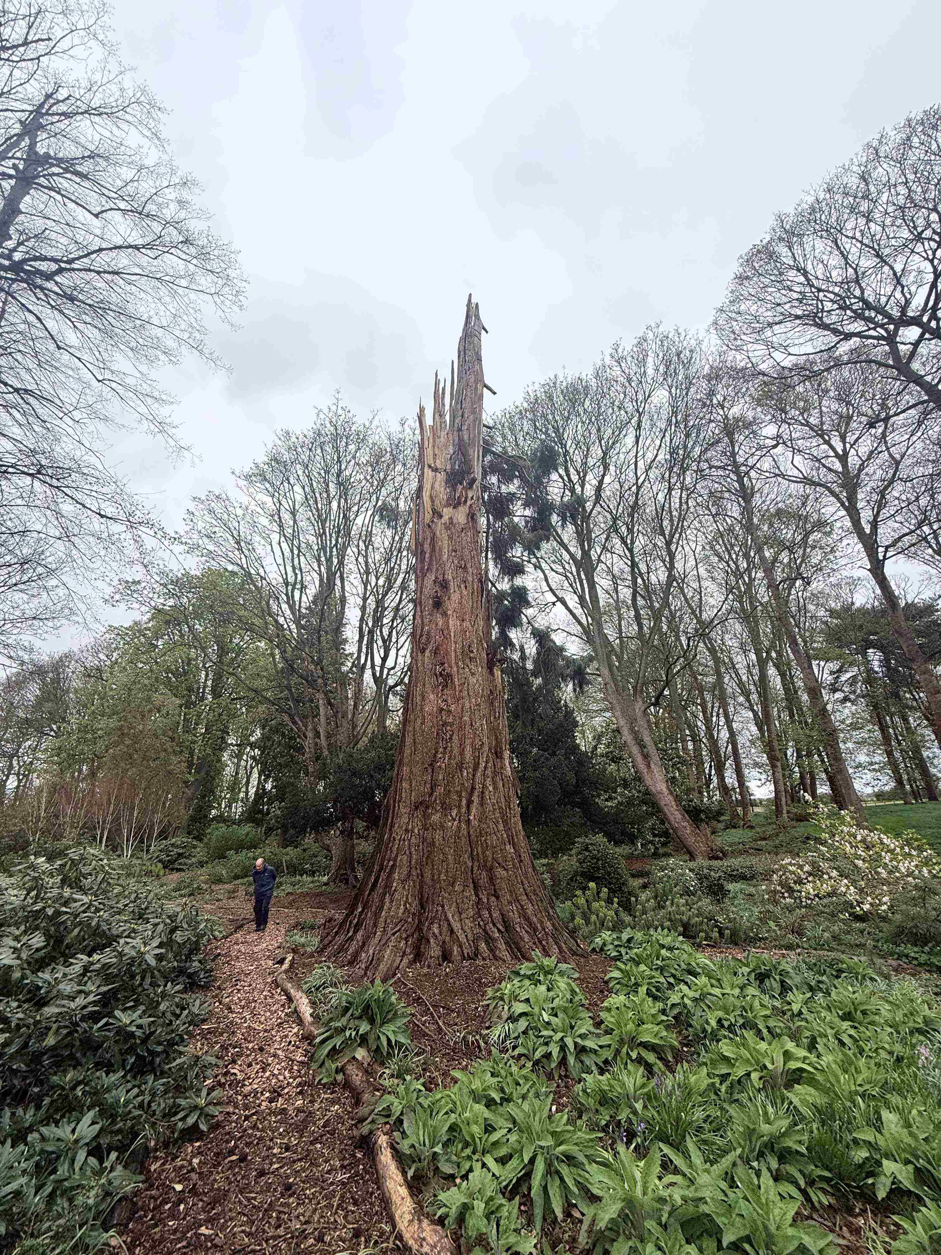

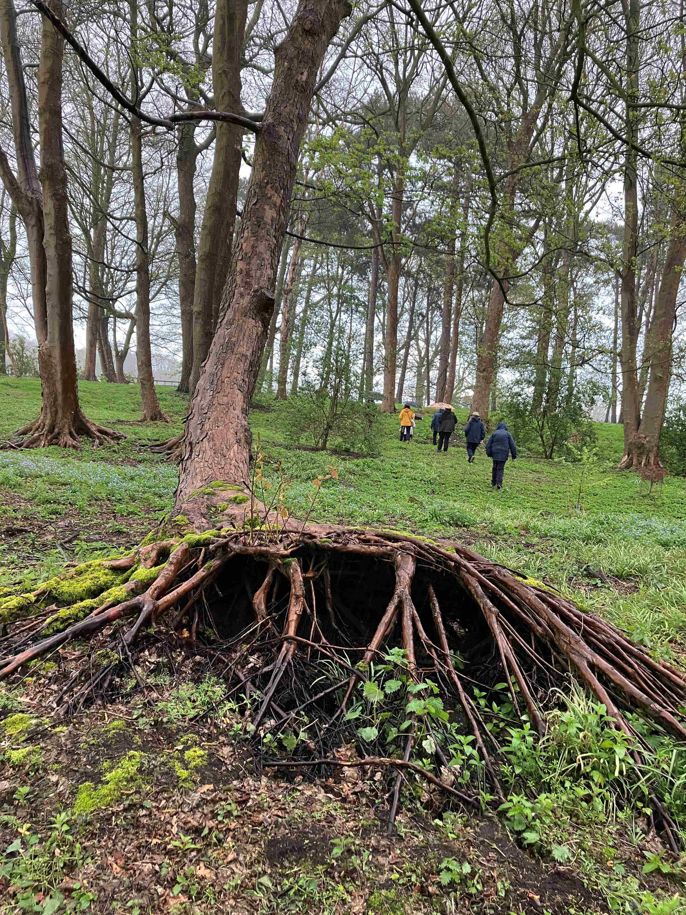Figure 2: Migrating Hornbeam (Hughes)

Severn Tree Trust Programme of Events for 2026.

Please note that Visits are for members only and Talks are open to all.
Non-members will be asked for a contribution of £5 and to become a member please see the ‘Join Us’ section on our website:
severntreetrust.co.uk

Full details about Visits will appear in the Newsletter.

Talks will be held at the Shropshire Wildlife Trust, Abbey Foregate, Shrewsbury, at 7 for 7.30pm.

Severn Tree Trust Programme 2026*

January = No meeting

February 10th = Forests of Central China. Talk by Andrew Allott.

March 10th = AGM + ‘Perthshire, Big Tree County’ Talk by John Tuer.

Sunday, 29th April = Visit: Oakgates, Telford.

May 9th = Visit: Bolesworth Castle, Tattenhall (Sat.): Self lead.

June 13th = Visit: Willey Estate, Broseley (Sat.)

July 15th = Visit: Birmingham Inst. for Forest Research (Wed.) BIFOR

August = No meeting

Sept. 12th = Visit: Gredington, Hanmer (Sat.)

October 11th = Visit: Gatley Park, Leominster

November 10th = A fascinating Talk by Bob Watson. Refreshments.

December 8th = Urban Woodland Initiatives: their past and present in creating better places for people and nature. Talk by Tristan Haynes Christmas Social & Refreshments

*meetings are subject to change depending on weather and other events. Please see monthly newsletters for updates.
THE SEVERN TREE TRUST – Membership Renewal 2026

Renew your membership – the easy way
We're always saying that we must keep up with events and then not doing anything about it! So we really must do something and the best way to start is with your membership renewals. If a number of you have had difficulty in renewing your STT memberships for 2026, you can do so by using BACS.

Our account name is Severn Tree Trust
Our bank's sort code is: 08 92 99
and our Account Number is: 65401288

But please add your name where it asks for a reference. We've had problems with some members not giving their name on the bank transfer and it's been difficult to sort out who you are. So name please if you wish to use BACS.

We do hope that makes things a lot easier for you but if you want to pay annually by Standing Order (not Direct Debit note because with Standing Order you control your payments), please ask us for the approriate form. Hoping that's helpful.

To renew your membership by cheque, please complete the following and send it to our Treasurer.

John Tuer, Evergreen, 5 Woodside, Homer, Much Wenlock, TF13 6NQ

(please tick as appropriate)
Single Adult membership (£15) ______ Under 21s Membership (£5)________

Double Adult Membership (£30)__________

Title (Mr.) (Mrs.) (Ms.) (Miss) (Dr.)

Name(s)____________________________________________________________________________________________________________________________

__________________________________________________________________

Please confirm your email address. _______________________________

Address_____________________________________________________________________________________________________________________________________________________________________________________________________

Receipt of newsletter. If possible we would like to send you the newsletter by email as it saves on postal costs. However our editor will post it to you if you have no email access.The newsletter is always available on the website https://severntreetrust.co.uk. Thank you for renewing your membership. We look forward to seeing you at our meetings.

