July 2026
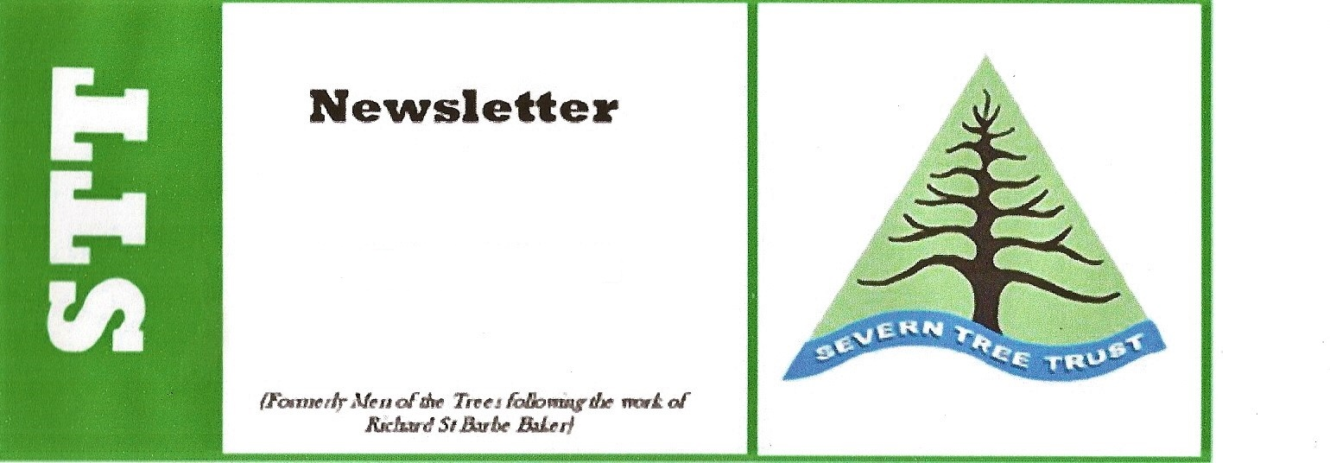
IMPORTANT: VISIT NOW AT 10 a.m.

Visit to BIFOR Wednesday 15th July @10 am. As you may remember from our last visit there is a need to find out how many members are coming to BIFOR so please do let Andrew Allott know on;
07422730833 or email andrewjallott@gmail.com

A big thanks to John for writing the article about our last visit to the Willey Estate. Despite one or two problems with locating the meeting place, it went very well. The motto was, always have an OS map handy as all this technology does not always work in deepest, darkest Shropshire. STT gave a donation to the local Saxon church, St Giles at Barrow, which is well worth exploring, we plan to next time we are in the area.

For staffing reasons our July visit is on a WEDNESDAY the 15th at 9.30am for a 10am start as it belongs to Birmingham University. BiFor FACE (Birmingham Institute for Forest Research Free Air Carbon Dioxide Enrichment) is one of only two such experiments on the planet. STT last looked at the work almost a decade ago soon after it began so it will be fascinating to see how it has progressed.
BiFor is at Norbury Junction which itself is an interesting village where what remains of the Shrewsbury Canal meets the Shropshire Union. It is north-east of Newport, follow the A519 and after about six miles there are bold, brown tourist signs pointing to Norbury Junction. The roads are quite narrow so cross over the canal bridge and follow the road passing the car park and cafe for about a quarter mile. BiFor is carved into a huge log on the left and just after that on the left is the visitor's car park. If you look where the road continues into a tunnel which is actually beneath one of the greatest earthworks of the canal age, the colossal Shelmore Embankment.
For those who want to explore beyond a STT visit, it is well worth parking by the cafe or Junction Inn (there are frequent rumours that some members like a pub meal after a visit), and walking along the embankment a couple of hundred yards southwards as there is the surreal view of all the steel equipment protruding through the tree canopy. And the tamest herons you will ever come across.

For some years now we have had a group of final year forestry and farming students (Harper Adams) visiting the farm. Last year one of them had had his year out at BiFor and the neighbouring Norbury Estate. This year we had something quite different. The Uni has begun an agroecology course so we had a ruck of mature students on that course but also fourteen farmers and educators from across Africa (mainly Nigeria, Zimbabwe and Uganda) so the questioning was quite intense. I always demand of visitors very tough criticism. The one thing above all else which I learnt from it was how narrow climatic conditions many people are comfortable with. One of the next visiting groups is from the River Teme catchment area (Teme CaBa) so we'll see if the flooding problem can be sorted out in the south of the county.
Finally a couple of mentions about places STT members might have visited in the past. John Ravenscroft, the owner of Cherry Tree Arboretum at Woore, died a few weeks ago. I will always remember his tale of how leverets used to sit at the entrance to the greenhouses at Bridgemere Garden Centre watching the staff. And The Laskett Garden owned by Sir Roy Strong, which he gifted to charity a few years back has been dismantled by auction and now on the market for £1.5 million. He must be disappointed at the very least.

Once again the next meeting is on Wednesday 15th July with a maximum number of twenty so (and apologies for this) please contact me or another member of committee well beforehand if you intend to come along. silvaspinpeter@aol.com or 01948840073. If you have to cancel later, please also inform us. Peter Aspin

Visit to the Woodland of Willey Estate: Saturday, 13th June 2026
This visit consisted of a guided walk through a mixed woodland belonging to the Willey Estate, near Broseley, which belongs to Lord Forester. Our guide was Terry Merchant, an arboricultural and forestry consultant who had been working for the Willey Estate for years. He certainly knew the woodland like the proverbial back of his hand and, had he left us high and dry, it is doubtful that we would have found our way back to our cars. But of course he didn't and he was most knowledgeable and informative during our tour.
Woodland accounts for 600 hectares (10%) of the Estate and it is very much, I repeat, a mixed woodland, a very healthy woodland with, perfectly naturally, trees dying and lots of new regeneration. So what species are there here. Amongst the broadleaved deciduous, lots of Beech, Oak, Rowan, Downy Birch were included, and amongst the conifers were Larch, which figured prolifically, Douglas Fir, Coast Redwood, Grand Fir, Western Hemlock and Sitka Spruce. Amazingly, Sitka Spruce was a great regenerator. Large groups of this species were springing up in lots of places where there were gaps in the canopy. Where the gaps had no regeneration, actual planting had taken place with a number of different species being used – Weymouth Pine, White Pine for example and a number of species already there (e.g. Western Hemlock, Beech, Oak ) – but these were placed in protective fencing to keep them away from the large groups of deer – Roe Deer and Muntjacs – that are found here in this woodland. The regenerated Sitkas are immune from deer damage. The animals don't like the sharpness of their needles. All other planted species are protected which can be a costly business.
So here we have a woodland of multi-layers, multi-ages, and multi-species all looking very healthy just as a normal vibrant mixed woodland should look. Gaps are filled in whenever necessary, particularly after such wind-throws as occurred during storm Dara recently and from time to time timber is extracted for commercial purposes. And this leads me to the thrust of Terry's talk as we walked with him through the trees. I have known Terry for a long time and even years ago, he was a member of the “continuous forest cover group”. He is now even more convinced of the benefits of this and, as woodland advisor to this Estate, he is recommending continuous forest cover all the time.

Some of you will know all about this, but for those of you who don't, please let me re-iterate some of things he told us about this idea. Firstly, he is totally opposed to monoculture in a woodland/forest. There is no age or species mix in these forests so disease is more likely to occur and spread. They are not natural to a landscape and once they are removed, row by row, they leave ugly acreages behind that take some time before they can recover enough to replant.
With continuous forest cover, selected trees are removed, still leaving a mixed woodland as I said before, of mixed heights, mixed ages and mixed species as close to a natural woodland as one could get. As for as possible, too, the newly regenerated trees are from seed which already abounds in the woodland, rather than from seed artificially brought in from elsewhere and alien to the site.
Terry's talk during our walk was interesting and illuminating and we thank him for taking time to come and take us round this beautiful woodland, a woodland of which Willey Estates can be immensely proud. Thank you too, to Selina, of the Forester family, for providing us with some cakes on our return to the cars. An exceptionally good visit. John Tuer
Norbury Park
Norbury Park Estate was purchased by the current owners in 2009. 1,300 acres of the estate is mature woodland. Part of this is being used for a huge international experiment, in collaboration with Birmingham University’s Institute of Forestry (BIFoR). It is a Free Air Carbon Dioxide Enrichment (FACE) experiment and is one of three so far established in natural ecosystems around the world. The BIFoR FACE experiment is in mature oak woodland. Atmospheric carbon dioxide concentrations in circular trial areas are being raised during the growing season each year. The target concentration is 550 ppm, which is the level predicted for the year 2045. FACE experiments allow research into the response of the whole woodland ecosystem to rising carbon dioxide levels.
Since 2009 the estate has embarked on a massive re-afforestation programme by planting trees on the poorer quality arable land. To date almost 400 acres of new woodland has been created and over half a million trees planted. More than a hundred different species have been planted, in mixed species plantations, with the aim of promoting in faster growth and better resistance to pests and diseases than in monocultures. The trees are initially planted at high densities, with the best and largest trees subsequently selected and encouraged by ‘halo-pollarding’ of the smaller surrounding trees, to reduce competition. This management technique is carried out on a 4-5 year rotation to leave a 1-2 meter canopy gap around the ‘winning’ trees allowing them ample room for growth and in the future to become high-quality sawlogs. The smaller pollarded and felled trees are used for timber, fire-logs and woodchip to fuel the estate’s own biomass boilers and kiln.
In an associated project, the estate has established a seed orchard containing 109 different tree species from around the world. These species have been selected for their potential as alternative timber producers in the UK. In each case strains of the species have been planted that have superior timber-producing quality.
750 acres of the estate have been converted from arable to herbal leys, mob-grazed by cattle. The aim is to improve soil structure and sequester carbon.

